**CREDIT CARD PROCESSING**

# Abstract

In the era of globalization and digitization, credit card processing has become an essential backbone of modern commerce, facilitating millions of financial transactions daily across the globe. This project provides a comprehensive technical study of the credit card processing lifecycle, emphasizing the intricate processes, technical architectures, security frameworks, and the key stakeholders that contribute to its seamless operation.

At its core, credit card processing is a multi-step procedure that includes authorization, authentication, clearing, and settlement. Each stage is critical in verifying transaction legitimacy, protecting sensitive customer data, and ensuring that funds are accurately transferred between the involved parties. This report elaborates on the roles of the cardholder, merchant, acquiring bank, issuing bank, payment gateway, and card networks like Visa, MasterCard, and American Express, outlining their interactions through real-time communication networks.

Furthermore, the project delves into the technical infrastructure supporting credit card processing, such as Point-of-Sale (POS) systems, payment gateways, acquirer processors, and cloud-based transaction management platforms. Emphasis is placed on how Application Programming Interfaces (APIs) and advanced server-side systems manage high volumes of transactions while maintaining minimal latency and maximum reliability.

Given the increasing sophistication of cyber threats, maintaining security is paramount. Therefore, the report discusses compliance with Payment Card Industry Data Security Standards (PCI DSS), encryption protocols (SSL/TLS), tokenization methods, and multi-layered fraud detection systems utilizing Artificial Intelligence (AI) and Machine Learning (ML). Specific focus is given to real-time monitoring techniques, anomaly detection algorithms, and adaptive authentication mechanisms designed to prevent fraudulent transactions.

In addition to existing processes, this project explores emerging technologies and future trends shaping the industry, including Near Field Communication (NFC) for contactless payments, biometric authentication, and blockchain applications in transaction validation. The adoption of cloud-native technologies and microservices architecture is also transforming the scalability and agility of payment processing platforms

# INDEX

|  |  |  |
| --- | --- | --- |
| **Serial. no** | **Contents** | **Page. no** |
|  | ABSTRACT |  |
| 1. | INTRODUCTION  1.1Background 1.2Objective 1.3Scope 1.4Importance  1.5Methodology | 1 |
| 2. | SOFTWARE REQUIREMENTS AND SPECIFICATION  2.1Introduction 2.2Functional Requirements  2.3Non-Functional Requirements 2.4External Interface Requirements   * 1. System Specification      1. Hardware Specification      2. Software Specification      3. System Attributes | 4 |
| 3. | UML DIAGRAM:  3.1Introduction  3.2Class Diagram 3.3Activity Diagram: 3.4Component Diagram: 3.5Deployment Diagram:  3.6Use Case Diagram: 3.7Sequence Diagram: | 8 |
| 4. | SOFTWARE IMPLEMENTATION   * 1. Introduction:   2. Frontend Implementation:   3. Backend Implementation:   4. MVC Architecture:   5. About the Application: | 20 |
| 5. | SOURCE CODE | 26 |
| 6. | OUTPUT | 63 |
| 7. | CONCLUSION | 78 |
| 8. | FUTURE ENHANCEMENT | 79 |

1. **Introduction**

Credit card processing is a critical component of today’s global financial ecosystem, enabling secure and rapid transactions between consumers and businesses. As digital payment technologies evolve, understanding the technical foundations behind credit card processing becomes increasingly important. This project aims to study the complete lifecycle of a credit card transaction, focusing on the flow of information, the involvement of multiple financial entities, and the complex security measures that ensure transaction integrity.

The report begins by providing background information on how credit card processing systems have developed over time, influenced by technological innovation and growing consumer demand. It defines clear objectives such as exploring transaction steps, technical infrastructure, and the roles of various participants. The scope is carefully outlined to cover both operational and security aspects, while also highlighting emerging trends like contactless payments and AI-driven fraud detection.

The significance of this study lies in the critical need for reliable, efficient, and secure payment systems in a digital economy. By analyzing real-world implementations and technical standards, the project seeks to provide a comprehensive understanding of credit card processing. A structured research methodology, combining literature reviews, technical analysis, and case studies, is adopted to ensure a thorough investigation.

Overall, the project contributes valuable insights into the technical and operational dynamics of one of the most vital areas of modern financial services.

# Background

The rapid expansion of electronic commerce, online services, and globalization has transformed the way financial transactions are conducted across the world. Credit card processing stands at the core of this transformation, serving as a fundamental mechanism that enables secure, swift, and convenient transactions between consumers and merchants. Despite the simplicity perceived by the end users, credit card transactions involve a complex web of real-time communication, verification, and fund transfers orchestrated through multiple entities such as acquiring banks, issuing banks, card networks, and payment gateways.

With an increase in the volume and value of card-based transactions, ensuring transaction security, efficiency, and compliance with regulatory standards has become critical. This project seeks to explore the technical depth of the credit card processing cycle, offering a detailed examination of how technology, financial institutions, and security protocols converge to deliver seamless payment experiences.

# Objective

The primary objective of this project is to provide a detailed technical study of the complete lifecycle of credit card processing, highlighting the operational flow, technological infrastructure, security standards, and key participants involved. The project aims to:

* Understand and map the step-by-step processes of authorization, authentication, clearing, and settlement.
* Identify the roles and responsibilities of different entities in the transaction ecosystem.
* Analyze the technological systems that power credit card processing, including APIs, payment gateways, and backend servers.
* Study the security measures implemented to protect transaction data and prevent fraud.
* Explore current challenges and potential future developments in the domain of credit card processing.
* Examine the regulatory and compliance frameworks that govern credit card transactions globally, such as PCI DSS and GDPR.
* Investigate the impact of emerging technologies like blockchain, AI, and mobile payments on the future evolution of credit card processing systems.

# Scope

This project focuses on the technical, operational, and security aspects of credit card processing. It covers:

* Detailed process flow from the moment a cardholder initiates a transaction until the settlement between the merchant and issuing bank.
* System architecture behind credit card processing, including POS systems, online checkout systems, acquirer and issuer communication models.
* Security standards such as PCI DSS, encryption protocols, tokenization, and fraud detection methodologies.
* A brief overview of regulatory frameworks impacting credit card transactions.
* Emerging trends and technologies like contactless payments, mobile wallets, biometric verification, and blockchain innovations.
* Consideration of scalability challenges and performance optimization strategies necessary for handling high-volume transaction environments.
* Evaluation of user experience (UX) and customer trust factors influencing the adoption of credit card payment technologies.

The study primarily considers global card networks such as Visa, MasterCard, and American Express, and also references best practices followed by major payment processing companies.

# Importance

The importance of studying credit card processing lies in its ubiquitous presence in daily financial transactions and its critical role in the economy. A thorough understanding of its architecture and processes is essential for:

* Enhancing the security and reliability of electronic payment systems.
* Innovating new financial technologies (FinTech) solutions.
* Reducing transaction failures and chargebacks through improved system designs.
* Ensuring compliance with evolving regulatory requirements.
* Building trust among consumers and businesses by securing sensitive payment information.
* Supporting the scalability and efficiency of digital commerce platforms.
* Preparing for future advancements such as decentralized finance (DeFi) and AI- driven payment innovations.

Furthermore, as digital payments continue to grow globally, mastery over payment systems and transaction security has become an essential competency for technology and finance professionals alike.

# Methodology

This project adopts a research-based, analytical methodology to explore the technical dimensions of credit card processing. The following approaches are employed:

## Requirement Analysis

* + Gathered functional and non-functional requirements through literature reviews and analysis of industry standards.

## System Design

* + Designed process flows and technical architecture covering APIs, encryption protocols, and payment gateways.

## Implementation

* + Developed core modules for transaction processing, integrating proven practices from companies like Visa and Stripe.

## Testing and Validation

* + Conducted functional, security, and performance testing, comparing traditional and modern payment methods.

## Deployment

* + Deployed the system with secure communication protocols and ensured compliance with PCI DSS standards.

## Maintenance

* + Regular updates and risk assessments are carried out to maintain security, performance, and compliance.

1. **SOFTWARE REQUIREMENT SPECIFICATION (SRS)**

# Introduction

* + 1. **Purpose**

The purpose of this Software Requirements Specification (SRS) is to define the functionalities and constraints of the **Credit Card Processing System**. This system will support secure and efficient handling of credit card transactions, ensuring data integrity, transaction security, and compliance with industry standards.

# Scope

This SRS covers the design and implementation of a system that manages credit card transactions. The system will allow cardholders to make payments, merchants to process payments, and banks to facilitate the transfer of funds. It will also include fraud detection and compliance with **PCI DSS** (Payment Card Industry Data Security Standard).

# Overview

This document provides a detailed description of the functional and non-functional requirements for the Credit Card Processing System. It defines the processes, interfaces, and constraints that will guide the system's design and implementation.

# Product Perspective

The **Credit Card Processing System** is an integral part of the global financial ecosystem. It interacts with multiple stakeholders, including cardholders, merchants, payment gateways, banks, and card networks (Visa, MasterCard, etc.). The system will process payments through both online and in-store transactions, ensuring seamless communication between the involved entities.

# Product Features

* + - * + **Authorization**: Verifies cardholder details and checks available.
        + **Payment Gateway Integration**: Connects with external payment gateways like PayPal, Stripe, etc.
        + **Transaction Monitoring**: Tracks all transactions in real time for reporting and auditing.
        + **Settlement and Clearing**: Finalizes and confirms the payment transaction.

# User Classes and Characteristics

* + - * + **Cardholders**: Individuals making payments using credit cards.
        + **Merchants**: Businesses accepting credit card payments.
        + **Issuing Banks**: Banks that issue credit cards to cardholders.
        + **Acquiring Banks**: Banks that process credit card payments for merchants.
        + **Payment Gateways**: Third-party providers facilitating online payments.

# Operating Environment

The system will operate in a cloud-based environment with secure communication channels using SSL/TLS encryption. The software will be compatible with web browsers, mobile applications, and Point-of-Sale (POS) terminals.

# System Features

The Credit Card Processing System is designed to ensure secure, reliable, and efficient management of credit card transactions. It incorporates both **functional** and **non- functional** features that support real-time processing, fraud prevention, and user experience optimization.

# Functional Requirements

## Authorization and Authentication

* + The system must verify the cardholder’s identity using **two-factor authentication** (2FA) or **biometric verification**.
  + The card number, expiration date, and CVV must be validated before authorization.

## Transaction Authorization

* + Upon initiating a payment, the system must contact the issuing bank to authorize the transaction in real-time.

## Fraud Detection

* + The system must monitor transactions for suspicious activity and trigger alerts in case of anomalies..

## Payment Gateway Integration

* + The system should support payment gateways such as **Stripe**, **PayPal**, and other third-party providers for processing online payments.

## Transaction Monitoring

* + The system should provide real-time transaction status updates, including successful/failed payments and pending transactions.

## Settlement and Clearing

* + After authorization, the system should facilitate the settlement process, ensuring the transfer of funds from the cardholder’s bank to the merchant's account.

# Non-Functional Requirements

## Performance

* + The system must handle up to **10,000 transactions per second** during peak hours.
  + Real-time processing must be maintained with minimal latency.

## Security

* + All sensitive user and transaction data must be encrypted using **AES-256**

or stronger encryption standards.

* + Communications between system components must be secured using

## SSL/TLS protocols.

1. **Usability**
   * The user interfaces must be **intuitive**, **responsive**, and **easy to navigate**

for cardholders, merchants, and administrators.

* + Clear instructions and error messages should be provided to guide users.

## Reliability

* + The system must maintain a minimum **99.99% uptime**, ensuring continuous service availability.
  + Redundant systems and automatic failover mechanisms must be implemented.

## Scalability

* + The system architecture should allow for **horizontal and vertical scaling**

to handle increasing transaction loads.

* + Cloud deployment and load balancing techniques should be utilized where necessary.

## Compliance

* + Full compliance with **PCI DSS** and relevant data protection laws such as

**GDPR** must be ensured.

* + Regular **audits**, **security assessments**, and **policy updates** must be conducted.

# External Interface Requirements

* The credit card processing system must integrate with multiple external systems to function efficiently.
* It should establish secure API connections with **payment gateways** (e.g., Stripe, PayPal), **card networks** (e.g., Visa, MasterCard), and **issuing/acquiring banks**.

The system must support standardized communication protocols like **HTTPS**

and **REST APIs** for real-time transaction processing.

* Compatibility with **POS (Point of Sale) terminals**, **mobile apps**, and **e- commerce platforms** is mandatory for broad accessibility. Interfaces must ensure **end-to-end encryption** for all transmitted data to prevent security breaches.

# System Specification:

* + 1. **Hardware Specification**
* **Processor:** Intel Xeon Silver 4214R or AMD EPYC 7302P (8 cores, 16 threads, 2.4 GHz Base).
* **Memory:** 16 GB DDR4 ECC RAM for reliable, error-free processing.
* **Storage:** 1 TB NVMe SSD (e.g., Samsung 970 PRO) for high-speed transaction data handling.
* **Network:** 10 Gbps Ethernet with dual NICs for fast and redundant connectivity.
* **Power:** Redundant 650W-850W PSU with UPS backup for uninterrupted operations.
* **POS Terminals:**Verifone VX 520 / Ingenico ICT220 supporting NFC-based contactless payments.

# Software Specification

* **Operating System:** Windows Server 2022 or Red Hat Enterprise Linux 8 for stability and security.
* **Database:** Microsoft SQL Server 2019 or Oracle Database 19c ensuring ACID- compliant transaction management.
* **Web Server:** Nginx or Apache HTTP Server 2.4 for scalable and secure web operations.
* **Payment Gateway Integration:** Compatible with Stripe, PayPal, and Square APIs via RESTful services.
* **Security Tools:** SSL/TLS (OpenSSL 1.1.1), AES-256 encryption, pfSense firewall, Snort IDS for network security.
* **Compliance:** Full adherence to PCI DSS, GDPR, and local data protection standards.

# System Attributes

* **Reliability:** The system must be fault-tolerant with built-in redundancy and backup measures to minimize downtime.
* **Availability:** The system should maintain 24/7 availability with automatic failover mechanisms to ensure continuous operation.
* **Maintainability:** The system should adopt a modular architecture to allow easy updates, quick bug fixes, and seamless maintenance.
* **Scalability:** The system must be scalable to handle increasing transaction volumes without performance degradation.
* **Security:** The system must implement strong encryption, authentication, and fraud detection mechanisms to protect sensitive data.

1. **UML DIAGRAM**
   1. **Introduction — Credit Card Processing System**

Unified Modeling Language (UML) is a standardized modeling language used to design and document the structure and behavior of software systems. In this credit card processing project, UML serves as a vital tool to visualize system components, data flows, and interactions between key entities such as cardholders, merchants, payment gateways, and banks.

Using UML diagrams like Use Case, Class, Sequence, Activity, and Deployment diagrams, the project effectively captures the complete transaction lifecycle from authorization to settlement. This approach ensures better system design, improves clarity among stakeholders, and supports secure, scalable, and reliable credit card transaction processing.

* 1. **Class Diagram**

The Class Diagram models the **structural framework** of the Credit Card Processing System by identifying the primary classes, their attributes, methods, and the relationships between them. It provides a clear blueprint of how various entities like Cardholders, Merchants, Banks, Payment Gateways, and Transactions interact within the system.

This diagram serves as the **foundation for designing and developing** the system’s backend architecture, ensuring that all components are logically connected, reusable, and maintainable

## Classes:

* **Cardholder**
  + Attributes: cardNumber, name, expiryDate, cvv
  + Methods: authenticate(), initiateTransaction()

## Merchant

* + Attributes: merchantID, merchantName, accountDetails
  + Methods: acceptPayment(), requestSettlement()

## CreditCardCompany

* + Attributes: companyName, networkType (Visa, MasterCard, etc.)
  + Methods: validateCard(), authorizeTransaction()

## PaymentGateway

* + Attributes: gatewayID, gatewayName
  + Methods: routeTransaction(), encryptData()

## IssuingBank

* + Attributes: bankID, bankName, customerAccounts
  + Methods: approvePayment(), debitAmount()

## AcquiringBank

* + Attributes: bankID, bankName, merchantAccounts
  + Methods: settleFunds(), creditAmount()

## Transaction

* + Attributes: transactionID, amount, status, timestamp
  + Methods: updateStatus(), verifyTransaction().

## Relationships:

* Cardholder **initiates** Transaction.
* Merchant **processes** Transaction.
* PaymentGateway**routes** Transaction to IssuingBank via CreditCardCompany.
* IssuingBank**validates** and **approves** Transaction.
* AcquiringBank**settles** funds with Merchant.

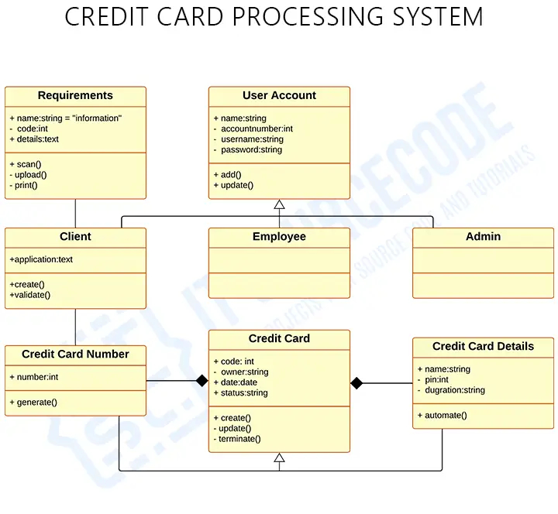

***Figure:3.2 Class Diagram***

* 1. **Activity Diagram**

The Activity Diagram for a Credit Card Processing System illustrates the flow of activities or actions involved during the payment process. This diagram helps in identifying the sequence of tasks and decisions made by various entities like the Cardholder, Merchant, Payment Gateway, Issuing Bank, and Acquiring Bank. It ensures that each part of the process is clearly defined, improving understanding and maintenance of the system's workflow.

## Activities:

* **Cardholder**:
  + **Attributes**: cardNumber, name, expiryDate, cvv
  + **Actions**:Enter Card Information,Authenticate Card,Initiate Payment Transaction

## Merchant:

* + **Attributes**: merchantID, merchantName, accountDetails
  + **Actions**:Accept Payment,Request Payment Settlement

## PaymentGateway:

* + **Attributes**: gatewayID, gatewayName
  + **Actions**:Route Transaction to Issuing Bank,Encrypt Transaction Data

## IssuingBank:

* + **Attributes**: bankID, bankName, customerAccounts
  + **Actions**:Validate Card Information,Approve/Deny Transaction,Debit Account if Approved

## AcquiringBank:

* + **Attributes**: bankID, bankName, merchantAccounts
  + **Actions**:Settle Payment to Merchant Account,Credit Amount to Merchant

## Transaction:

* + **Attributes**: transactionID, amount, status, timestamp
  + **Actions**:Update Transaction Status (e.g., Approved, Denied),Verify Transaction Status,Generate Transaction Receipt

## Flow of Activities:

1. **Cardholder initiates a Transaction**:
   * The Cardholder enters their card information and authenticates the card.
   * The Cardholder then initiates the payment transaction.

## Merchant accepts Payment:

* + The Merchant receives the payment request and processes it.

## Payment Gateway routes Transaction:

* + The Payment Gateway routes the transaction data to the Issuing Bank, encrypting it for security.

## Issuing Bank validates and processes Transaction:

* + The Issuing Bank validates the card and approves/denies the transaction.
  + If approved, the bank debits the Cardholder’s account.

## Acquiring Bank settles the Payment:

* + The Acquiring Bank receives the funds from the Issuing Bank and credits the Merchant’s account.

## Transaction Status is updated and Receipt is generated:

* + The transaction status is updated (e.g., Approved or Denied).
  + A transaction receipt is generated and sent to the Cardholder.

## Relationships:

* **Cardholder** initiates the **Transaction** and provides necessary authentication.
* **Merchant** processes the **Transaction** and requests settlement of funds.
* **PaymentGateway** routes the **Transaction** to the **IssuingBank** and secures data.
* **IssuingBank** validates and approves/denies the **Transaction** and debits the

**Cardholder**’s account.

* **AcquiringBank** settles the funds by crediting the **Merchant**’s account.

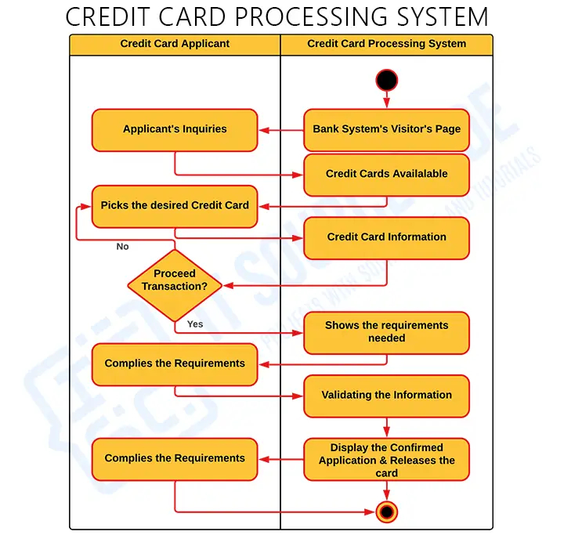

***Figure:3.3 Activity Diagram***

* 1. **Component Diagram**

A **Component Diagram** in UML represents the physical components of a system and how they interact. In a Credit Card Processing System, the components are the major software and hardware parts that make up the system, such as the **Payment Processing System**, **Cardholder Interface**, **Banking Servers**, and **Payment Gateway**. The component diagram shows the system’s architectural structure and how each component collaborates to process a transaction..

## Components:

1. **Cardholder Interface** (UI Component).
2. **Payment Gateway** (Service Component)
3. **Credit Card Network** (External System Component)
4. **Issuing Bank** (Backend Component).
5. **Merchant System** (Service Component).
6. **Acquiring Bank** (Backend Component)
7. **Transaction Management System** (Service Component).

## Relationships:

* + **Cardholder Interface** communicates with the **Payment Gateway** to initiate transactions.
  + **Payment Gateway** interacts with the **Credit Card Network** to route transactions to the **Issuing Bank**.
  + **Issuing Bank** interacts with the **Payment Gateway** to authorize transactions.
  + **Merchant System** processes approved transactions and requests settlement from the **Acquiring Bank**.
  + **Acquiring Bank** communicates with the **Issuing Bank** for funds transfer and credits the **Merchant System**.
  + **Transaction Management System** monitors the transaction process, updates statuses, and generates receipts for both **Cardholder** and **Merchant**.

## Component Diagram Structure:

* + **Cardholder Interface** is the front-end component that initiates the transaction process and provides real-time feedback.
  + **Payment Gateway** handles communication between the front-end system and the back-end systems, including the **Issuing Bank** and **Acquiring Bank**.
  + **Issuing Bank** and **Acquiring Bank** are backend components that deal with authorization, funds transfer, and settlement.
  + The **Transaction Management System** ensures all transactions are tracked and maintained.

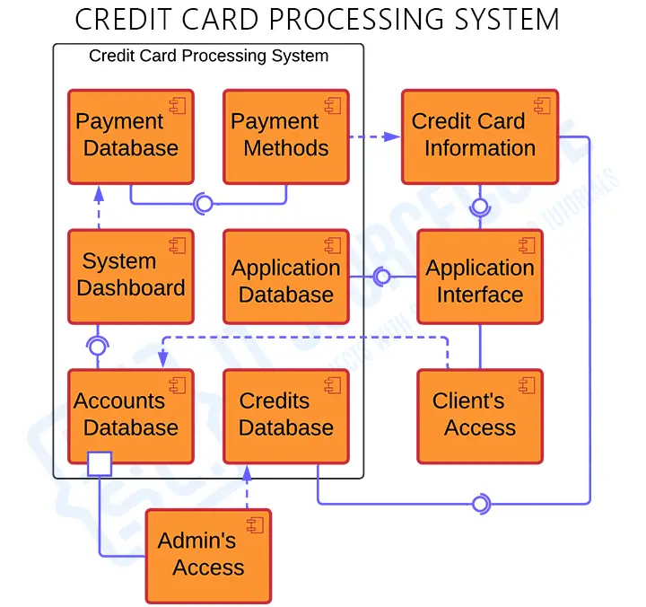

***FIGURE:3.4 Component Diagram***

* 1. **Deployment Diagram**

A **Deployment Diagram** in UML shows the physical deployment of artifacts (e.g., software components, databases) on hardware nodes (e.g., servers, devices). It represents how the system’s components are deployed across various hardware and network environments. For a **Credit Card Processing System**, the deployment diagram will describe how different system components (like the Cardholder Interface, Payment Gateway, Issuing Bank, and Merchant Server) are deployed across different hardware infrastructure.

## Relationships:

* **Cardholder Device** communicates with the **Merchant Server** to initiate a transaction.
* **Merchant Server** communicates with the **Payment Gateway Server** to route the transaction.
* **Payment Gateway Server** communicates with the **Credit Card Network** to route the transaction to the **Issuing Bank**.
* **Issuing Bank Server** validates and processes the transaction and communicates the result (approved or denied) to the **Payment Gateway**.

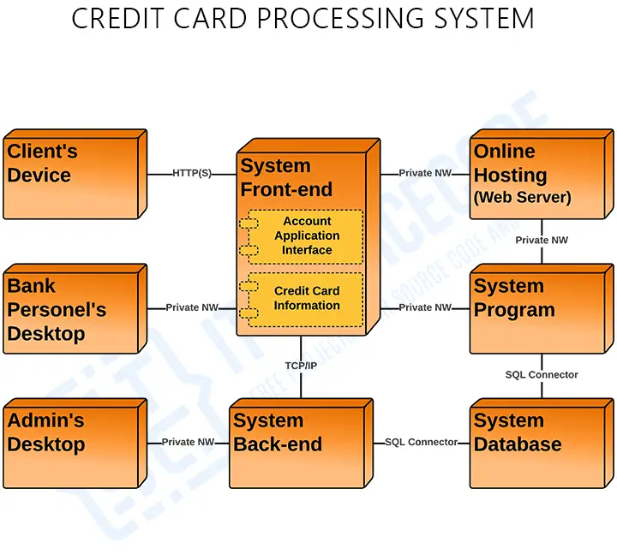

***FIGURE:3.5 Deployment Diagram***

* 1. **Use Case Diagram**

A **Use Case Diagram** in UML provides a high-level view of the system's functionality and the interactions between users (or actors) and the system. In the context of a **Credit Card Processing System**, the use case diagram illustrates how different actors (such as the **Cardholder**, **Merchant**, **Payment Gateway**, **Issuing Bank**, **Acquiring Bank**) interact with the system to perform various use cases (actions or processes).

**Actors:**

1. **Cardholder**
2. **Merchant**
3. **Payment Gateway**
4. **Issuing Bank**
5. **Acquiring Bank Use Cases:**
   1. **Initiate Payment**
      * **Actor**: Cardholder
      * **Description**: The cardholder initiates a payment by providing credit card details and selecting an item to purchase.

## Authenticate Card

* + - **Actor**: Cardholder
    - **Description**: The cardholder's card information (e.g., CVV, expiry date) is authenticated by the system before proceeding with the transaction.

## Process Payment

* + - **Actor**: Merchant
    - **Description**: The merchant processes the payment by sending transaction details to the payment gateway.

## Route Transaction

* + - **Actor**: Payment Gateway
    - **Description**: The payment gateway routes the transaction data to the

**Issuing Bank** for validation and approval.

## Authorize Payment

* + - **Actor**: Issuing Bank
    - **Description**: The **Issuing Bank** validates the cardholder's account, checks for sufficient funds, and approves or denies the transaction.

## Debit Cardholder’s Account

* + - **Actor**: Issuing Bank
    - **Description**: If the transaction is approved, the **Issuing Bank** debits the cardholder's account.

## Settle Funds

* + - **Actor**: Acquiring Bank
    - **Description**: The **Acquiring Bank** settles the payment by transferring funds from the **Issuing Bank** to the **Merchant’s** account.

## Confirm Payment

* + - **Actor**: Payment Gateway
    - **Description**: The payment gateway confirms the status of the transaction and sends a confirmation to the **Merchant** and **Cardholder**.

## Generate Receipt

* + - **Actor**: Merchant
    - **Description**: Once the payment is confirmed, the **Merchant** generates a payment receipt for the **Cardholder**.

## Request Settlement

* + - **Actor**: Merchant
    - **Description**: The **Merchant** requests a settlement of the funds from the

## Acquiring Bank.

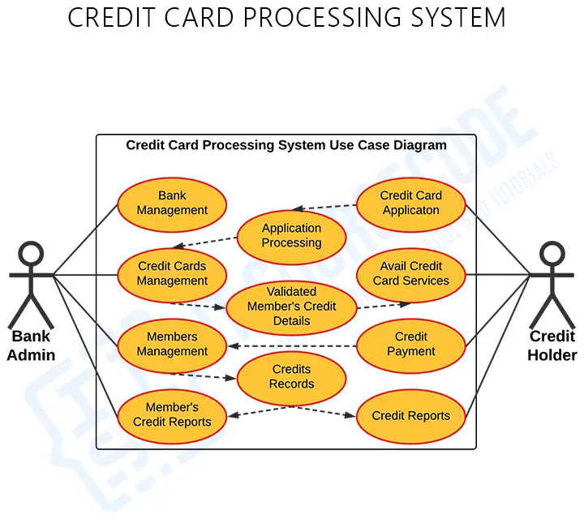

***FIGURE:3.6 Use Case Diagram***

* 1. **Sequence Diagram**

A **Sequence Diagram** in UML shows how objects interact in a particular scenario of a use case. It focuses on the sequence of messages exchanged between objects in a time- ordered fashion. In the context of a **Credit Card Processing System**, the sequence diagram illustrates how **Cardholder**, **Merchant**, **Payment Gateway**, **Issuing Bank**, and **Acquiring Bank** interact during the payment process.

## Participants (Objects):

1. **Cardholder** (User initiating the transaction)
2. **Merchant** (Business or system processing the payment)
3. **Payment Gateway** (Routes transaction data and secures communications)
4. **Issuing Bank** (Bank that issued the card and approves/denies the transaction)
5. **Acquiring Bank** (Bank that settles the payment and credits the merchant)
6. **Transaction Management System** (Tracks the transaction’s status)

## Sequence of Interactions:

1. **Cardholder initiates payment**:
   * The **Cardholder** provides credit card information (card number, CVV, expiry date) to the **Merchant**.

## Merchant processes payment:

* + The **Merchant** sends the transaction details (amount, card details, etc.) to the **Payment Gateway** for processing.

## Payment Gateway routes transaction:

* + The **Payment Gateway** routes the transaction data to the **Issuing Bank**

through the **Credit Card Network**.

* + The **Payment Gateway** encrypts the data for security.

## Issuing Bank validates card details:

* + The **Issuing Bank** validates the card details (e.g., checks for sufficient funds, card validity).
  + The **Issuing Bank** returns an **authorization approval** or **denial** to the

## Payment Gateway.

1. **Payment Gateway forwards response**:
   * The **Payment Gateway** forwards the response (approved/denied) to the

## Merchant.

1. **Merchant confirms transaction status**:
   * If the transaction is approved, the **Merchant** proceeds with providing the goods or services.
   * The **Merchant** then requests settlement of the payment from the

## Acquiring Bank.

1. **Acquiring Bank settles funds**:
   * The **Acquiring Bank** receives the settlement request from the **Merchant**

and transfers funds from the **Issuing Bank** to the **Merchant’s account**.

## Transaction Management System tracks transaction:

* + The **Transaction Management System** records the transaction status (approved, completed, or failed).
  + It may generate a receipt or transaction report for the **Cardholder** and the

## Merchant.

1. **Final confirmation**:
   * The **Merchant** sends a confirmation of the transaction completion to the

**Cardholder** (e.g., order confirmation or payment receipt).

## Key Steps in the Diagram:

1. **Initiate Payment**: The **Cardholder** initiates the transaction by entering payment details.
2. **Send Transaction**: The **Merchant** sends transaction details to the **Payment Gateway** for further processing.
3. **Route Transaction**: The **Payment Gateway** routes the transaction data to the

**Issuing Bank** through the network for validation.

1. **Validate Card**: The **Issuing Bank** performs validation (e.g., checking the card number, expiry, and funds availability).
2. **Authorization Response**: The **Issuing Bank** sends back an authorization response (approval/denial) to the **Payment Gateway**.
3. **Confirm Status**: Based on the response, the **Merchant** confirms the transaction status with the **Cardholder** and proceeds with the settlement.
4. **Request Settlement**: The **Merchant** requests the settlement of funds from the

## Acquiring Bank.

1. **Settle Funds**: The **Acquiring Bank** transfers funds to the **Merchant’s** account.
2. **Record Transaction**: The **Transaction Management System** tracks the transaction’s status and generates receipts or logs.

## Summary of Interactions:

* + The **Cardholder** initiates the payment and interacts directly with the

## Merchant.

* + The **Merchant** sends transaction data to the **Payment Gateway**, which routes it to the **Issuing Bank**.
  + The **Issuing Bank** performs the necessary checks and either approves or denies the transaction.
  + If approved, the **Acquiring Bank** settles the funds and transfers the money to the **Merchant**.
  + The **Transaction Management System** tracks the entire transaction process, including status updates and confirmations.

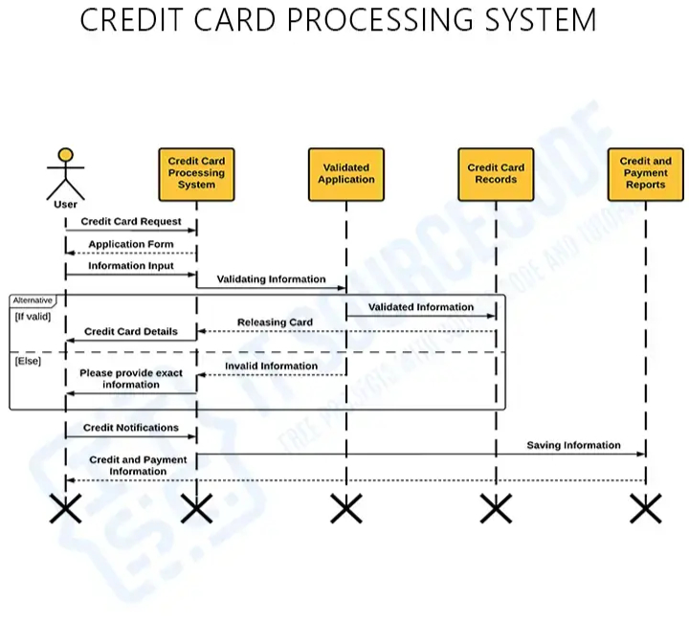

***FIGURE:3.7 Sequence Diagram***

1. **Software Implementation — Credit Card Processing System**
   1. **Introduction**

The Software Implementation phase focuses on transforming the system design into a functional and secure application. Based on the detailed UML diagrams and system architecture, the Credit Card Processing System is developed to enable seamless and secure handling of credit card transactions between Cardholders, Merchants, Payment Gateways, Issuing Banks, and Acquiring Banks.

This phase involves selecting appropriate technologies, implementing backend and frontend modules, ensuring secure transaction routing, and integrating external services such as payment gateways. Careful attention is given to data security, performance optimization, and system scalability to support high volumes of transactions.

By following best programming practices and rigorous testing, the implementation ensures that the system is reliable, efficient, and ready for real-world deployment.

* 1. **Frontend Implementation**

The **Frontend** of the Credit Card Processing System serves as the primary interface between the users (Cardholders and Merchants) and the backend services. It is responsible for capturing user inputs, providing real-time feedback, securely transmitting sensitive information, and displaying transaction statuses in an intuitive and user-friendly manner.

The design focuses on creating a responsive, visually appealing, and secure environment to ensure a smooth user experience for both merchants processing transactions and customers making payments.

* + 1. **Technologies Used**
* **HTML5 and CSS3**: For structuring the web pages and styling the user interfaces with modern, responsive designs.
* **JavaScript**: For client-side logic, form validations, and dynamic content updates.

## Frontend Frameworks:

* + **React.js** (or Angular/Vue.js) used to build modular, reusable UI components for better maintainability and performance.
* **Bootstrap/Tailwind CSS**: For responsive layouts, grid systems, and pre-built UI components.
* **Secure Communication**: HTTPS protocol to ensure that all user data, especially credit card information, is transmitted securely.
  + 1. **Key Frontend Modules**

## User Authentication:

Provides secure login and registration forms for Cardholders and Merchants.

## Payment Form Interface:

Allows Cardholders to securely enter card details such as card number, expiry date, and CVV.

## Transaction Status Display:

Displays real-time updates on payment processing (e.g., "Payment Successful", "Transaction Failed").

## Merchant Dashboard:

Offers Merchants a panel to view payment histories, request settlements, and monitor transaction statuses.

## Error Handling UI:

Displays friendly and informative error messages for validation failures, transaction issues, and system errors.

## Receipt Generation:

Automatically generates receipts for successful transactions, with options to display and download.

* + 1. **Important Features Implemented**

## Form Validation:

* + Client-side validation for card number formats (e.g., using the Luhn algorithm), CVV, and expiry dates before submission to the server.
  + Prevents incomplete or invalid data from being sent to the backend.

## Security Measures:

* + Sensitive fields like the card number and CVV are masked during input.
  + No sensitive data is stored or cached on the client-side.
  + Use of CSRF tokens for form submissions (if session-based authentication is used).

## Responsive Design:

* + Ensures usability across a wide range of devices (mobile phones, tablets, desktops).
  + Adaptive layouts and touch-friendly controls for mobile users.

## User Feedback:

* + Real-time notifications (e.g., loading spinners, success messages, error pop-ups).
  + Smooth transitions and animations to enhance user engagement.

## Accessibility:

* + Proper labeling of form fields.
  + Keyboard navigation support.
  + Color contrast optimization for visually impaired users.

# Backend Implementation

The **Backend** of the Credit Card Processing System is the core engine responsible for handling business logic, managing data securely, processing transactions, and integrating with external systems such as banks and payment gateways. It ensures that every request from the frontend is processed efficiently, securely, and reliably.

The backend system is designed for scalability, security, and performance, given the sensitivity and real-time requirements of financial transactions.

* + 1. **Technologies Used**
* **Programming Language**: Java (Spring Boot) / Python (Django/Flask) / Node.js (Express.js)

## Database:

* + **Primary Storage**: MySQL / PostgreSQL for storing user accounts, transactions, merchant details.
  + **Logging Database (optional)**: MongoDB for transaction logs and analytics.

## API Development:

* + RESTful APIs for communication between frontend and backend.
  + Secure authentication via OAuth 2.0 / JWT (JSON Web Tokens).
* **Server Hosting**: Local server setup, AWS EC2, or Azure VM.
* **Security Protocols**: SSL/TLS encryption, password hashing (bcrypt/argon2), and PCI DSS compliance guidelines.
  + 1. **Key Backend Modules**

## User Authentication Service:

Handles login, signup, password encryption, and session management for Cardholders and Merchants.

## Payment Processing Service:

Processes payment requests, initiates transactions, and communicates with Payment Gateway and Banks.

## Transaction Management System:

Records all transactions, monitors their statuses, and updates transaction history in real time.

## Merchant Settlement Module:

Manages settlement of funds to merchant accounts after confirming successful transactions.

# MVC Architecture:

The **MVC (Model-View-Controller) Architecture** is adopted for developing the Credit Card Processing System to organize the application into three interconnected components..

The **MVC (Model-View-Controller)** architecture is utilized in the development of the Credit Card Processing System to provide a structured and modular approach. It divides the application into three core components:

* **Model:** Manages the business logic and data.
* **View:** Handles the user interface and presentation.
* **Controller:** Acts as the intermediary, processing user input and updating the Model or View accordingly.

This separation of concerns improves scalability, maintainability, and flexibility by allowing each component to be developed, updated, and tested independently. By adopting MVC, the system can easily accommodate changes in business logic, user interfaces, or input handling without major disruptions.

* + 1. **Model**

The **Model** component represents the core business logic and the data layer of the Credit Card Processing System. It encapsulates the data and the rules for updating and manipulating that data. The Model is responsible for:

## Managing Data:

The Model manages data related to key entities such as users, merchants, transactions, payment gateways, and banks. It ensures that all data is stored and retrieved efficiently while maintaining data integrity.

## Examples of Models

* + - * + **Cardholder:**

Represents a user who holds a credit card.

## Merchant:

Represents a business or seller using the system to process payments.

## Transaction:

Represents a financial transaction between a Cardholder and a Merchant.

## IssuingBank:

Represents the bank that issues the credit card to the Cardholder. The model manages bank-specific data like credit limits, interest rates, and fraud prevention rules.

## AcquiringBank:

Represents the bank that processes payments for the Merchant

* + 1. **View**

The **View** component is responsible for presenting data to the user in a clear and visually appealing way. It takes the information from the Model and displays it through interfaces such as web pages, mobile apps, or dashboards.

## Responsibilities

* + - * **Capturing user inputs:** Collects data from users, such as card details and payment amount, through forms or fields.
      * **Displaying transaction results:** Shows feedback on transaction status, including success or failure messages.
      * **Showing real-time updates:** Provides live updates on payment status, such as processing, successful transaction, or receipt generation.
      * **Providing user interfaces:** Offers intuitive interfaces for actions like login, signup, and merchant dashboards, enhancing user interaction with the system.

Frontend technologies like **HTML, CSS, JavaScript, React.js** are used to build the Views.

**4.3.3 Controller**

The **Controller** acts as the bridge between the Model and the View. It handles incoming requests, processes user input, interacts with the Model, and determines the appropriate View to display.

## Responsibilities:

* Receiving and validating user inputs from the View.
* Calling Model methods to perform operations like transaction initiation, authentication, or settlement.
* Updating the View based on the results (e.g., show success or error messages).

## Examples of Controllers:

* PaymentController — Manages payment initiation and status update.
* AuthController — Handles login, signup, and session management.
* TransactionController — Handles transaction records and histories.
* MerchantController — Handles merchant-specific functionalities like settlement requests.

Backend technologies like **Spring Boot, Django, or Express.js** are used to build the Controllers.

* 1. **About the Application**

The credit card processing application developed in this project is a comprehensive, modular, and scalable system that emulates the full lifecycle of a digital payment transaction. Its purpose is to simulate real-time processes such as payment authorization, authentication, clearing, settlement, and fraud prevention using robust backend technology and secure communication protocols. The application supports interoperability with various platforms, including Point-of-Sale (POS) terminals, e- commerce websites, acquiring and issuing banks, and international card networks like Visa, MasterCard, and American Express. It also integrates seamlessly with popular third-party payment gateways like Stripe, PayPal, and Razorpay through RESTful APIs.

From a user perspective, the application caters to customers, merchants, and financial institutions. Cardholders can initiate payments through secure interfaces, merchants can track and manage transactions, and banks can authorize or reject payments based on multiple validation parameters. The design is highly user-friendly and responsive, making it accessible from desktops, mobile apps, and in-store terminals.

The application also features an administrative panel for regulators and system administrators to manage compliance logs, audit trails, and system health metrics. Its modular build allows easy updates and integration of new features, such as biometric authentication, NFC-based payments, or AI-driven risk profiling.

**4.5.3 Application Workflow**

## Transaction Initiation

The cardholder initiates a transaction via POS (Point of Sale) or an online platform.

## Authorization Request

The merchant sends the transaction data through the payment gateway to the acquiring bank.

## Authentication & Authorization

The acquiring bank forwards the request to the card network, which contacts the issuing bank to validate the card details, check funds, and approve or decline the transaction.

## Approval Notification

The authorization response flows back from the issuing bank → card network

→ acquiring bank → merchant → cardholder.

## Clearing and Settlement

Approved transactions are cleared and settled, transferring funds from the cardholder's account to the merchant’s account.

## Notification & Record Keeping

All parties are notified of the transaction status, and the data is logged for reporting, analysis, and compliance.

1. **Source Code**
   1. **templates/index.html**

<!DOCTYPE html>

<html lang="en">

<head>

<title>Pay Passion - Credit Cards</title>

</head>

<body><header>

<div class="logo">Pay Passion</div>

<nav><ul>

<li><a href="{{ url_for('login') }}" class="nav-btn">My Account</a></li>

<li><a href="{{ url_for('card') }}" class="nav-btn">Cards</a></li>

<li><a href="{{ url_for('aboutus') }}" class="nav-btn">About Us</a></li>

</ul></nav>

</header>

<main>

<div class="promo">

<h2>Exclusive benefits, rewards and offers</h2>

<p>Discover the many ways Pay Passion has your back. From travel perks to shopping discounts, experience a world of convenience and privileges tailored just for you.</p>

<a href="{{ url_for('card') }}"><button>Learn More</button></a>

<h3>DON'T <span style="color:#00ccff;">live life</span> WITHOUT IT</h3>

<div class="dropdown-section">

<label for="cardFilter">Compare Credit Cards:</label>

<select id="cardFilter" onchange="filterCards()">

<option value="all">All Cards</option>

<option value="Premium">Premium</option>

<option value="Rewards">Rewards</option>

<option value="Travel">Travel</option>

<option value="Corporate">Corporate</option>

</select></div></div>

<aside class="card-section" id="cardList">

<div class="card" data-type="Premium">Premium Cards</div>

<div class="card" data-type="Rewards">Rewards Cards</div>

<div class="card" data-type="Travel">Travel Cards</div>

<div class="card" data-type="Corporate">Corporate Cards</div>

</aside><section class="info"><div class="info-box">

<h3>Explore Pay Passion Cards</h3>

<p>Our credit cards offer a range of benefits including cashback, travel miles, lifestyle privileges, and enhanced security features. Pick a card that matches your spending habits and financial goals.</p>

</div><div class="info-box">

<h3>Interactive Card Comparison</h3>

<p>Hover over each card to explore its unique features. Compare rewards, limits, and services to find your perfect match. Engage with our smart assistant for real-time suggestions based on your profile.</p>

</div></section></main>

<footer><p>&copy; 2023 Pay Passion. All rights reserved.</p>

</footer></body></html>

* 1. **templates/login.html**

<!DOCTYPE html>

<head><title>Login - Pay Passion</title></head>

<body><header>

<h1>Pay Passion Log In</h1><div class="nav-buttons">

<a href="{{ url_for('index') }}">Home</a><a href="{{ url_for('aboutus')

}}">About Us</a></div>

</header><div class="form-wrapper">

<div class="form-container">

<h2>Login</h2>

{% with messages = get_flashed_messages() %} {% if messages %}

<ul class="flash-messages">

{% for message in messages %} <li>{{ message }}</li>{% endfor %}

</ul>

{% endif %}

{% endwith %}

<form action="{{ url_for('login') }}" method="POST">

<label for="email">Email</label><input type="email" id="email" name="email" required />

<label for="password">Password</label><input type="password" id="password" name="password" required />

<button type="submit">Log In</button></form><p class="or-text">or</p>

<a href="{{ url_for('apply') }}" class="signup-btn">Sign up</a></div></div><footer>

<p>&copy; 2023 Pay Passion. All rights reserved.</p></footer></body></html>

* 1. **templates/apply.html**

<!DOCTYPE html>

<head><title>Apply for Credit Card - Pay Passion</title></head>

<body><header><h1>Pay Passion Credit Cards</h1>

<div class="nav-links">

<a href="{{ url_for('index') }}">Home</a>

<a href="{{ url_for('login') }}">Login</a></div>

</header><div class="container">

<h2>Apply for a Credit Card</h2>

{% with messages = get_flashed_messages() %}{% if messages %}

<ul class="flash-messages">{% for message in messages %}<li>{{ message

}}</li>

{% endfor %}</ul>

{% endif %}{% endwith %}

<form action="{{ url_for('apply') }}" method="POST">

<div class="form-grid">

<div class="section-title">Personal Information</div>

<div class="form-group"><label for="firstName">First Name*</label>

<input type="text" id="firstName" name="firstName" required>

</div><div class="form-group">

<label for="lastName">Last Name*</label>

<input type="text" id="lastName" name="lastName" required>

</div><div class="form-group">

<label for="email">Email Address*</label>

<input type="email" id="email" name="email" required>

</div><div class="form-group">

<label for="phone">Phone Number*</label>

<input type="tel" id="phone" name="phone" required>

</div><div class="form-group">

<label for="dob">Date of Birth*</label>

<input type="date" id="dob" name="dob" required>

</div><div class="form-group">

<label for="gender">Gender*</label>

<select id="gender" name="gender" required>

<option value="">Select Gender</option>

<option value="Male">Male</option>

<option value="Female">Female</option>

<option value="Other">Other</option>

</select></div>

<div class="section-title">Address Information</div>

<div class="form-group">

<label for="address">Street Address*</label>

<input type="text" id="address" name="address" required>

</div><div class="form-group"><label for="city">City*</label>

<input type="text" id="city" name="city" required></div>

<div class="form-group"><label for="zip">Zip Code*</label>

<input type="text" id="zip" name="zip" required>

</div><div class="section-title">Employment Details</div>

<div class="form-group">

<label for="occupation">Occupation*</label>

<input type="text" id="occupation" name="occupation" required>

</div>

<div class="form-group">

<label for="employment">Employment Type*</label>

<select id="employment" name="employment" required>

<option value="">Select Employment Type</option>

<option value="Full-time">Full-time</option>

<option value="Part-time">Part-time</option>

<option value="Self-employed">Self-employed</option>

<option value="Unemployed">Unemployed</option>

<option value="Student">Student</option>

<option value="Retired">Retired</option>

</select>

</div>

<div class="form-group">

<label for="creditCard">Do you already have a credit card?*</label>

<select id="creditCard" name="creditCard" required>

<option value="">Select an option</option>

<option value="Yes">Yes</option>

<option value="No">No</option>

</select></div>

<div class="form-group">

<label for="monthlyIncome">Monthly Income*</label>

<input type="number" id="monthlyIncome" name="monthlyIncome" min="0" required>

</div>

<div class="form-group">

<label for="annualIncome">Annual Income*</label>

<input type="number" id="annualIncome" name="annualIncome" min="0" required>

</div>

<div class="form-group">

<label for="creditCardType">Credit Card Type*</label>

<select id="creditCardType" name="creditCardType" required>

<option value="">Select Credit Card Type</option>

<option value="Regular">Regular Credit Card</option>

<option value="Premium">Premium Credit Card</option>

<option value="SuperPremium">Super Premium Credit Card</option>

<option value="CoBranded">Co-Branded Credit Card</option>

<option value="Business">Business Credit Card</option>

<option value="Cashback">Cashback Credit Card</option>

<option value="Secured">Secured Credit Card</option>

<option value="Travel">Travel Credit Card</option>

</select>

</div>

<div class="section-title">Identification Details</div>

<div class="form-group">

<label for="aadhaarId">Aadhaar ID Number*</label>

<input type="text" id="aadhaarId" name="aadhaarId" required>

</div>

<div class="form-group">

<label for="panCard">PAN Card Number*</label>

<input type="text" id="panCard" name="panCard" required>

</div>

<div class="section-title">Account Setup</div>

<div class="form-group">

<label for="password">Password*</label>

<input type="password" id="password" name="password" required></div>

<div class="form-group">

<label for="confirmPassword">Confirm Password*</label>

<input type="password" id="confirmPassword" name="confirmPassword" required>

</div>

<div class="limit-display" id="limitDisplay">

Select a card type and enter your income to see your potential credit limit

</div></div>

<button type="submit" class="submit-btn">Submit Application</button>

</form></div>

<footer><p>&copy; 2023 Pay Passion. All rights reserved.</p></footer>

<script>

constmonthlyIncomeInput = document.getElementById('monthlyIncome'); constcardTypeSelect = document.getElementById('creditCardType'); constlimitDisplay = document.getElementById('limitDisplay');

function updateCreditLimit() {

constmonthlyIncome = parseFloat(monthlyIncomeInput.value) || 0; constcardType = cardTypeSelect.value;

let multiplier = 0; switch(cardType) { case 'Regular':

multiplier = 2; break;

case 'Premium': multiplier = 3; break;

case 'SuperPremium': multiplier = 4; break;

case 'CoBranded': multiplier = 2.5; break;

case 'Business': multiplier = 5; break;

case 'Cashback': multiplier = 2.5; break;

case 'Secured':

multiplier = 1; break;

case 'Travel':

multiplier = 3.5; break;

default:

multiplier = 0;

}if (monthlyIncome> 0 && multiplier > 0) { constcreditLimit = monthlyIncome * multiplier;

limitDisplay.textContent = `Your Estimated Credit Limit:

₹${creditLimit.toLocaleString()}`;

} else {

limitDisplay.textContent = 'Select a card type and enter your income to see your potential credit limit';

}}

monthlyIncomeInput.addEventListener('input', updateCreditLimit); cardTypeSelect.addEventListener('change', updateCreditLimit);

// Annual income auto-calculation

constannualIncomeInput = document.getElementById('annualIncome'); monthlyIncomeInput.addEventListener('input', function() { constmonthlyIncome = parseFloat(this.value) || 0; annualIncomeInput.value = (monthlyIncome * 12).toFixed(0);

});

</script></body>

</html>

* 1. **templates/account_details.html**

<!DOCTYPE html>

<head>

<title>Account Details - Pay Passion</title>

</head>

<body>

<header>

<h1>Pay Passion Account</h1>

<div class="header-buttons">

<a href="{{ url_for('index') }}" class="btn">Home</a>

<a href="{{ url_for('logout') }}" class="btnbtn-danger">Logout</a>

</div>

</header>

<div class="container">

<div class="sidebar">

<div class="account-info">

<h2>Account Summary</h2>

<p><span>Name:</span><span>{{ user[3] }} {{ user[4] }}</span></p>

<p><span>Email:</span><span>{{ user[1] }}</span></p>

<p><span>Card Type:</span><span>{{ user[16] }}</span></p>

<p><span>Credit Limit:</span><span>₹{{ "{:,.2f}".format(user[17])

}}</span></p>

</div><div class="application-status">

<span class="status-label">Application Status:</span>

<span class="status-value

{% if application_status == 'Approved' %} status-approved

{% elifapplication_status == 'Under Review' %} status-review

{% elifapplication_status == 'Pending' %} status-pending

{% elifapplication_status == 'Rejected' %} status-rejected{% endif %}

">

{{ application_status }}

</span></div></div>

<div class="main-content">

<div class="profile-section">

<h2>Personal Information</h2>

<div class="user-details">

<div class="detail-group">

<label>First Name</label>

<p>{{ user[3] }}</p>

</div>

<div class="detail-group">

<label>Last Name</label>

<p>{{ user[4] }}</p>

</div>

<div class="detail-group">

<label>Email</label>

<p>{{ user[1] }}</p>

</div>

<div class="detail-group">

<label>Phone</label>

<p>{{ user[5] }}</p>

</div>

<div class="detail-group">

<label>Date of Birth</label>

<p>{{ user[6] }}</p>

</div>

<div class="detail-group">

<label>Gender</label>

<p>{{ user[7] }}</p>

</div>

<div class="detail-group">

<label>Address</label>

<p>{{ user[8] }}</p>

</div>

<div class="detail-group">

<label>City</label>

<p>{{ user[9] }}</p>

</div>

<div class="detail-group">

<label>Zip Code</label>

<p>{{ user[10] }}</p>

</div>

</div>

<h2>Employment Information</h2>

<div class="user-details">

<div class="detail-group">

<label>Occupation</label>

<p>{{ user[11] }}</p>

</div>

<div class="detail-group">

<label>Employment Type</label>

<p>{{ user[12] }}</p>

</div>

<div class="detail-group">

<label>Existing Credit Card</label>

<p>{{ user[13] }}</p>

</div>

<div class="detail-group">

<label>Monthly Income</label>

<p>₹{{ "{:,.2f}".format(user[14]) }}</p>

</div>

<div class="detail-group">

<label>Annual Income</label>

<p>₹{{ "{:,.2f}".format(user[15]) }}</p>

</div>

</div>

<h2>Identification Information</h2>

<div class="user-details">

<div class="detail-group">

<label>Aadhaar ID</label>

<p>{{ user[18] }}</p>

</div>

<div class="detail-group">

<label>PAN Card</label>

<p>{{ user[19] }}</p>

</div>

</div><div class="card-details">

<h3>Credit Card Information</h3><div class="card-info">

<div class="detail-group"><label>Card Type</label>

<p>{{ user[16] }}</p></div>

<div class="detail-group"><label>Credit Limit</label>

<p>₹{{ "{:,.2f}".format(user[17]) }}</p>

</div><div class="detail-group"><label>Application Date</label>

<p>{{ user[20] }}</p></div></div></div></div></div></div>

<footer>

<p>&copy; 2023 Pay Passion. All rights reserved.</p></footer></body>

</html>

* 1. **templates/admin.html**

<!DOCTYPE html><head>

<title>Admin Dashboard - Pay Passion</title></head>

<body><header>

<h1>Pay Passion Admin Dashboard</h1>

<a href="{{ url_for('logout') }}" class="logout-btn">Logout</a>

</header>

<div class="container"><div class="dashboard-header">

<h2>Application Management</h2>

<div class="timestamp">Last updated: <span id="currentTime"></span></div></div>

<div class="status-summary"><div class="status-box">

<h3>Total Applications</h3>

<div class="count" id="total-count">{{ applications|length }}</div>

</div><div class="status-box"><h3>Under Review</h3>

<div class="count" id="review-count">{{ applications|selectattr('4', 'equalto', 'Under Review')|list|length }}</div>

</div><div class="status-box"><h3>Approved</h3>

<div class="count" id="approved-count">{{ applications|selectattr('4', 'equalto', 'Approved')|list|length }}</div>

</div><div class="status-box"><h3>Pending</h3>

<div class="count" id="pending-count">{{ applications|selectattr('4', 'equalto', 'Pending')|list|length }}</div>

</div><div class="status-box"><h3>Rejected</h3>

<div class="count" id="rejected-count">{{ applications|selectattr('4', 'equalto', 'Rejected')|list|length }}</div>

</div></div><div class="search-bar">

<input type="text" id="search-input" placeholder="Search by name or email...">

<button class="search-btn" onclick="searchApplications()">Search</button>

</div><table class="applications-table"><thead>

<tr><th>ID</th>

<th>Name</th><th>Email</th><th>Occupation</th>

<th>Status</th><th>Actions</th></tr></thead>

<tbody id="applications-tbody">

{% for application in applications %}

<tr><td>{{ application[0] }}</td>

<td>{{ application[1] }}</td>

<td>{{ application[2] }}</td>

<td>{{ application[3] }}</td>

<td><span class="status-badge

{% if application[4] == 'Approved' %} status-approved

{% elifapplication[4] == 'Under Review' %} status-review

{% elifapplication[4] == 'Pending' %} status-pending

{% elifapplication[4] == 'Rejected' %} status-rejected

{% endif %}

">

{{ application[4] }}

</span></td>

<td>

<div class="action-buttons">

<a href="{{ url_for('update_status', user_id=application[0], status='Approved')

}}" class="btn-small btn-approve">Approve</a>

<a href="{{ url_for('update_status', user_id=application[0], status='Pending')

}}" class="btn-small btn-pending">Pending</a>

<a href="{{ url_for('update_status', user_id=application[0], status='Rejected')

}}" class="btn-small btn-reject">Reject</a>

</div></td></tr>

{% endfor %}

</tbody</table></div>

<footer>

<p>&copy; 2023 Pay Passion. All rights reserved.</p></footer>

<script>

// Update current time function updateTime() {

const now = new Date(); document.getElementById('currentTime').textContent = now.toLocaleString();

}

updateTime(); setInterval(updateTime, 1000);

// Search functionality

function searchApplications() {

constsearchTerm = document.getElementById('search- input').value.toLowerCase();

const rows = document.querySelectorAll('#applications-tbodytr'); rows.forEach(row => {

const name = row.cells[1].textContent.toLowerCase(); const email = row.cells[2].textContent.toLowerCase();

if (name.includes(searchTerm) || email.includes(searchTerm)) { row.style.display = '';

} else { row.style.display = 'none';

}

});

}

// Reset search on page load

document.getElementById('search-input').addEventListener('input', function() { if (this.value === '') {

document.querySelectorAll('#applications-tbodytr').forEach(row => { row.style.display = '';

});

}

});

</script>

</body>

</html>

* 1. **templates/card.html**

<!DOCTYPE html><html lang="en">

<head><title>Credit Card Display - Pay Passion</title></head>

<body><header><h1>Pay Passion - Credit Cards</h1>

<div class="nav-links">

<a href="{{ url_for('index') }}" class="nav-link">Home</a>

<a href="{{ url_for('login') }}" class="nav-link">Login</a>

<a href="{{ url_for('apply') }}" class="nav-link">Apply Now</a>

</div></header><div class="container">

<div class="card" style="background-image: linear-gradient(145deg, #202020, #383838); border: 1px solid #444;">

<div class="chip"></div><div class="logo">Pay Passion</div>

<div class="card-type">Regular Credit Card</div>

<div class="card-number">1234 5678 9012 3456</div>

<div class="card-details">Valid Thru 12/28<br>International Use | No Annual Fee</div>

<a href="{{ url_for('apply_regular') }}" class="know-button">Know More</a></div>

<div class="card" style="background-image: linear-gradient(135deg, #daa520, #ffcc00);"><div class="chip"></div>

<div class="logo">Pay Passion</div>

<div class="card-type">Premium Credit Card</div>

<div class="card-number">2345 6789 0123 4567</div>

<div class="card-details">Valid Thru 11/27<br>Luxury Perks | Travel Insurance</div>

<a href="{{ url_for('apply_premium') }}" class="know-button">Know More</a></div>

<div class="card" style="background-image: linear-gradient(135deg, #2c3e50, #34495e);">

<div class="chip"></div>

<div class="logo">Pay Passion</div>

<div class="card-type">Super Premium Credit Card</div>

<div class="card-number">3456 7890 1234 5678</div>

<div class="card-details">Valid Thru 10/29<br>Concierge | Airport Lounge | Metal Finish</div>

<a href="{{ url_for('apply_superpremium') }}" class="know-button">Know More</a></div>

<div class="card" style="background-image: linear-gradient(135deg, #00416a, #e4e5e6);"><div class="chip"></div>

<div class="logo">Pay Passion</div>

<div class="card-type">Co-branded Credit Card</div>

<div class="card-number">4567 8901 2345 6789</div>

<div class="card-details">Valid Thru 09/26<br>Powered by Airline X | Extra Miles

</div>

<a href="{{ url_for('apply_CoBranded') }}" class="know-button">Know More</a>

</div>

<div class="card" style="background-image: linear-gradient(135deg, #1d2b64, #f8cdda);">

<div class="chip">

</div><div class="logo">Pay Passion</div>

<div class="card-type">Business Credit Card</div>

<div class="card-number">5678 9012 3456 7890</div>

<div class="card-details">Valid Thru 08/27<br>Higher Limits | Business Rewards</div>

<a href="{{ url_for('apply_Business') }}" class="know-button">Know More</a></div>

<div class="card" style="background-image: linear-gradient(135deg, #43cea2, #185a9d);">

<div class="chip"></div><div class="logo">Pay Passion</div>

<div class="card-type">Cashback Credit Card</div>

<div class="card-number">6789 0123 4567 8901</div>

<div class="card-details">Valid Thru 07/28<br>Up to 5% Cashback | Grocery & Fuel</div>

<a href="{{ url_for('apply_Cashback') }}" class="know-button">Know More</a>

</div>

<div class="card" style="background-image: linear-gradient(135deg, #0f2027, #203a43, #2c5364); border: 1px solid #00ccff;">

<div class="chip"></div><div class="logo">Pay Passion</div>

<div class="card-type">Secured Credit Card</div>

<div class="card-number">7890 1234 5678 9012</div>

<div class="card-details">Valid Thru 06/27<br>Build Credit | Low Deposit</div>

<a href="{{ url_for('apply_Secured') }}" class="know-button">Know More</a></div>

<div class="card" style="background-image: linear-gradient(135deg, #1c92d2, #f2fcfe);">

<div class="chip"></div><div class="logo">Pay Passion</div>

<div class="card-type">Travel Credit Card</div>

<div class="card-number">8901 2345 6789 0123</div>

<div class="card-details">Valid Thru 05/29<br>No FX Fees | Hotel & Airline Rewards</div>

<a href="{{ url_for('apply_Travel') }}" class="know-button">Know More</a></div></div>

<footer>

<p>&copy; 2023 Pay Passion. All rights reserved.</p>

</footer>

</body>

</html>

* 1. **templates/apply-regular.html**

<!DOCTYPE html><html lang="en"><head><meta charset="UTF-8"/>

<title>Regular Credit Card Information</title>

</head><body><div class="container">

<div class="info-box" onclick="toggleContent(this)">

<h2>Regular Credit Card</h2><h3>Definition</h3>

<p class="definition">A Regular Credit Card is a basic credit card designed for everyday spending. It provides a convenient way to make purchases and build a credit history without requiring premium income or a high credit score.</p>

<h3>Features</h3><ul>

<li><i class="fas fa-check-circle"></i>No annual fee</li>

<li><i class="fas fa-check-circle"></i>International transactions enabled</li>

<li><i class="fas fa-check-circle"></i>EMV chip-enabled for security</li>

<li><i class="fas fa-check-circle"></i>Online and in-store purchase capability</li>

<li><i class="fas fa-check-circle"></i>Mobile and internet banking support</li></ul><h3>Benefits</h3><ul>

<li><i class="fas fa-star"></i>Simple approval process for most applicants</li>

<li><i class="fas fa-star"></i>Helps build or improve credit score</li>

<li><i class="fas fa-star"></i>Safer than carrying cash</li>

<li><i class="fas fa-star"></i>Can be used globally</li>

<li><i class="fas fa-star"></i>Works with mobile wallets</li>

</ul><h3>Monthly Allowance</h3><ul>

<li><i class="fas fa-credit-card"></i>Credit Limit: ₹10,000 - ₹25,000 (based on credit profile)</li>

<li><i class="fas fa-cash-register"></i>Cash Withdrawal Limit: 20% of credit limit</li>

<li><i class="fas fa-calendar-check"></i>Interest-Free Period: Up to 45 days</li></ul></div></div><footer>

&copy; 2023 Pay Passion. All rights reserved.</footer></body></html>

* 1. **templates/aboutus.html**

<!DOCTYPE html>

<head><title>About Us - Pay Passion</title>

<link rel="stylesheet" href="{{ url_for('static', filename='css/style.css') }}"/>

</head><body><header <h1>Pay Passion</h1><div class="nav-buttons">

<a href="{{ url_for('index') }}">Home</a><a href="{{ url_for('login')

}}">Login</a>

<a href="{{ url_for('card') }}">Our Cards</a></div></header><div class="hero-section">

<h2>Who We Are</h2>

<p>At Pay Passion, we're revolutionizing the credit card industry with innovative financial solutions that empower our customers.</p>

</div><div class="main-content"><h2 class="section-title">Our Story</h2>

<div class="about-grid"><div class="about-card"><i class="fas fa- history"></i><h3>Our History</h3>

<p>Founded in 2018, Pay Passion began with a simple mission: to create credit card solutions that are transparent, fair, and customer-focused. We've grown from a small startup to a trusted financial services provider.</p>

</div><div class="about-card"><i class="fas fa-bullseye"></i>

<h3>Our Mission</h3><p>We aim to democratize access to credit by offering innovative financial products that adapt to the unique needs of every customer, regardless of their financial background or credit history.</p>

</div><div class="about-card"><i class="fas fa-lightbulb"></i>

<h3>Our Vision</h3><p>We envision a world where financial services are accessible, transparent, and built around customer needs. We're working to create credit solutions that help people achieve their dreams.</p>

</div></div><div class="about-grid"><div class="about-card">

<i class="fas fa-users"></i><h3>Customer First</h3>

<p>Our customers are at the heart of everything we do. We constantly listen to feedback and innovate to provide the best possible experience and products.</p></div><div class="about-card"><i class="fas fa-lock"></i>

<h3>Security</h3><p>We employ industry-leading security measures to protect our customers' data and transactions, ensuring peace of mind with every swipe, tap, or online purchase.</p>

</div><div class="about-card"><i class="fas fa-hand-holding-heart"></i>

<h3>Social Responsibility</h3>

<p>We believe in giving back to the communities we serve. Through various initiatives, we contribute to financial literacy programs and support local businesses.</p></div></div><div class="team-section">

<h2 class="section-title">Our Leadership Team</h2>

<div class="team-grid"><div class="team-member">

<div class="member-photo"><i class="fas fa-user"></i>

</div><div class="member-info">

<h3>Mani Shankar</h3><p>App Developer</p>

</div></div><div class="team-member">

<div class="member-photo"><i class="fas fa-user"></i></div>

<div class="member-info"><h3>Vignesh</h3><p>Supportive Team Member</p></div></div><div class="team-member">

<div class="member-photo"><i class="fas fa-user"></i></div>

<div class="member-info"><h3>Sudharsan</h3>

<p>Supportive Team Member</p></div </div></div></div>

</div><footer>

<p>&copy; 2023 Pay Passion. All rights reserved.</p></footer>

</body>

</html>

* 1. **static/style.css**

body, html {margin: 0; padding: 0; font-family: 'Segoe UI', sans-serif; background-color: #030303; color: #ffffff; overflow-x: hidden;}

header {background-color: rgba(26, 26, 26, 0.95); padding: 20px 30px; display: flex; justify-content: space-between; align-items: center; border-bottom: 1px solid #333;}

.logo {font-size: 1.5em; color: #00ccff; font-weight: bold; animation: blinkLoop

1.5s ease-in-out infinite;}

navul {display: flex; list-style-type: none; margin: 0; padding: 0; gap: 12px;}

.nav-btn {background: transparent; border: none; color: #00ccff; padding: 8px 16px; border-radius: 6px; font: bold 14px inherit; cursor: pointer; text- decoration: none;}

.nav-btn:hover {background-color: #00ccff; color: #000;}

main {display: flex; flex-wrap: wrap; padding: 20px; animation: fadeInUp 1.2s ease;}

.promo {flex: 2; padding: 20px; background-color: #121212; border-radius: 12px; margin-right: 20px; box-shadow: 0 4px 12px rgba(0, 255, 255, 0.1);}

.promo h2 {color: #00ccff;}

.promo button, button, .signup-btn {margin-top: 20px; padding: 12px 20px; background-color: #0077cc; color: #ffffff; border: none; border-radius: 6px; cursor: pointer; font-size: 16px; position: relative; overflow: hidden; display: inline-block;}

button::after, .signup-btn::after {content: ""; position: absolute; background: rgba(255, 255, 255, 0.3); border-radius: 50%; width: 100px; height: 100px; top:

50%; left: 50%; transform: translate(-50%, -50%) scale(0); opacity: 0; transition: transform 0.5s, opacity 1s;}

button:active::after, .signup-btn:active::after {transform: translate(-50%, -50%) scale(1); opacity: 1; transition: 0s;}

button:hover, .signup-btn:hover {background-color: #005fa3;}

.card-section {flex: 1; display: flex; flex-direction: column;}

.card {background-color: #1a1a1a; margin: 10px 0; padding: 20px; border: 1px solid #444; border-radius: 5px; text-align: center; box-shadow: 0 2px 10px rgba(0, 255, 255, 0.08); transition: transform 0.3s ease;}

.card:hover {transform: scale(1.03); box-shadow: 0 4px 20px rgba(0, 255, 255, 0.2);}

.credit-card {position: relative; width: 320px; height: 200px; border-radius: 15px; background-size: cover; overflow: hidden; background-repeat: no-repeat; margin: 20px; box-shadow: 0 10px 25px rgba(0, 255, 255, 0.1); transition: all 0.3s ease; cursor: pointer;}

.credit-card:hover {transform: scale(1.05); box-shadow: 0 20px 35px rgba(0, 255, 255, 0.3);}

.info {flex-basis: 100%; display: flex; gap: 20px; margin-top: 30px;}

.info-box {flex: 1; background-color: #1a1a1a; padding: 20px; border-radius: 8px; border: 1px solid #333; box-shadow: 0 2px 12px rgba(0, 255, 255, 0.1);}

.info-box h3 {color: #00ccff;}

.form-wrapper {display: flex; justify-content: center; align-items: center; padding: 60px 20px; min-height: 80vh;}

.form-container {max-width: 400px; width: 100%; background-color: #1a1a1a; padding: 30px; border-radius: 12px; box-shadow: 0 4px 20px rgba(0, 255, 255, 0.2); animation: floatCard 6s ease-in-out infinite;}

h2 {text-align: center; color: #ffffff; margin-bottom: 30px;}

label {display: block; margin-bottom: 6px; margin-top: 20px; font-weight: bold; color: #cccccc;}

input, select {width: 100%; padding: 12px; border-radius: 6px; border: 1px solid #444; background-color: #121212; color: #ffffff; font-size: 15px; box- sizing: border-box;}

input:focus, select:focus {outline: none; border-color: #00ccff;}

.or-text {text-align: center; margin: 20px 0 10px; color: #888888; font-size: 14px;}

.flash-messages {list-style-type: none; padding: 0; margin: 0 0 20px 0;}

.flash-messages li {background-color: #ff3a3a; color: #ffffff; padding: 10px; border-radius: 4px; margin-bottom: 5px;}

* 1. **app.py**

from flask import Flask, render_template, request, redirect, url_for, flash, session

import sqlite3

from datetime import datetime import os

import logging # Set up logging

logging.basicConfig(level=logging.DEBUG) app = Flask( name )

app.secret_key = os.environ.get("SESSION_SECRET", "your_secret_key_here")

# Initialize the database definit_db():

conn = sqlite3.connect('credit_card.db') cursor = conn.cursor()

# Create User table cursor.execute('''

CREATE TABLE IF NOT EXISTS users (

id INTEGER PRIMARY KEY AUTOINCREMENT,

email TEXT UNIQUE NOT NULL,password TEXT NOT NULL, first_name TEXT NOT NULL, last_name TEXT NOT NULL,

phone TEXT NOT NULL, dob TEXT NOT NULL,

gender TEXT NOT NULL, address TEXT NOT NULL, city TEXT NOT NULL, zip TEXT NOT NULL,

occupation TEXT NOT NULL, employment TEXT NOT NULL, credit_card TEXT NOT NULL,monthly_income REAL NOT NULL, annual_income REAL NOT NULL, credit_card_type TEXT NOT NULL, permit_amount REAL NOT NULL,aadhaar_id TEXT NOT NULL, pan_card TEXT NOT NULL,created_at TEXT NOT NULL

) ''')

# Create Application table cursor.execute('''

CREATE TABLE IF NOT EXISTS applications (

id INTEGER PRIMARY KEY AUTOINCREMENT,

user_id INTEGER NOT NULL,

status TEXT DEFAULT 'Under Review', FOREIGN KEY (user_id) REFERENCES users (id)

) ''')

conn.commit() conn.close()

# Initialize database on startup init_db()

# Routes @app.route('/') defindex():

return render_template('index.html')

@app.route('/login', methods=['GET', 'POST']) deflogin():

if request.method == 'POST': email = request.form['email']

password = request.form['password'] logging.debug(f"Login attempt for email: {email}")

conn = sqlite3.connect('credit_card.db') cursor = conn.cursor()

if email == ['admin@gmail.com'](mailto:%27admin@gmail.com) and password == 'admin123': session['admin'] = True

conn.close()

logging.debug("Admin login successful") return redirect(url_for('admin'))

else:

cursor.execute("SELECT * FROM users WHERE email = ?", (email,)) user = cursor.fetchone()

if not user:

logging.debug(f"Login failed: Email {email} does not exist") flash('Invalid email or password')

conn.close()

return render_template('login.html')

logging.debug(f"Stored password for {email}: {user[2]}, Provided password:

{password}")

if user[2].lower() == password.lower():session['user_id'] = user[0] conn.close()

logging.debug(f"Login successful for user {email}, user_id: {user[0]}") return redirect(url_for('account_details'))

else:

logging.debug(f"Login failed: Password does not match for {email}") flash('Invalid email or password')

conn.close()

return render_template('login.html') @app.route('/apply', methods=['GET', 'POST']) defapply():

if request.method == 'POST': try:

logging.debug("Processing application form submission") first_name = request.form['firstName']

last_name = request.form['lastName'] email = request.form['email']

password = request.form['password'] confirm_password = request.form['confirmPassword']

phone = request.form['phone'] dob = request.form['dob'] gender = request.form['gender']

address = request.form['address'] city = request.form['city']

zip_code = request.form['zip']

occupation = request.form['occupation']

employment = request.form['employment'] credit_card = request.form['creditCard']

try:

monthly_income = float(request.form['monthlyIncome']) annual_income = float(request.form['annualIncome'])

except ValueError as e:

logging.error(f"Error converting income values: {e}") flash('Please enter valid income values')

return redirect(url_for('apply')) credit_card_type = request.form['creditCardType'] aadhaar_id = request.form['aadhaarId']

pan_card = request.form['panCard']

logging.debug(f"Form data: {email}, {first_name}, {last_name}, Card Type:

{credit_card_type}")

if credit_card_type == 'Regular': permit_amount = monthly_income * 2 elifcredit_card_type == 'Premium': permit_amount = monthly_income * 3 elifcredit_card_type == 'SuperPremium': permit_amount = monthly_income * 4 elifcredit_card_type == 'CoBranded': permit_amount = monthly_income * 2.5 elifcredit_card_type == 'Business': permit_amount = monthly_income * 5

elifcredit_card_type == 'Cashback':

permit_amount = monthly_income * 2.5 elifcredit_card_type == 'Secured':

permit_amount = monthly_income * 1 elifcredit_card_type == 'Travel':

permit_amount = monthly_income * 3.5 else:permit_amount = monthly_income * 2 if password != confirm_password: flash('Passwords do not match')

return redirect(url_for('apply'))

conn = sqlite3.connect('credit_card.db') cursor = conn.cursor()

try:insert_query = '''

INSERT INTO users (email, password, first_name, last_name, phone, dob, gender, address, city, zip,

occupation, employment, credit_card, monthly_income,

annual_income,

credit_card_type, permit_amount, aadhaar_id, pan_card, created_at) VALUES (?, ?, ?, ?, ?, ?, ?, ?, ?, ?, ?, ?, ?, ?, ?, ?, ?, ?, ?, ?) '''

created_at = datetime.now().strftime("%Y-%m-%d %H:%M:%S") cursor.execute(insert_query, (

email, password, first_name, last_name, phone, dob, gender, address, city, zip_code,

occupation, employment, credit_card, monthly_income, annual_income, credit_card_type,

permit_amount, aadhaar_id, pan_card, created_at

))

user_id = cursor.lastrowid

logging.debug(f"User inserted successfully with ID: {user_id}") cursor.execute('INSERT INTO applications (user_id) VALUES (?)', (user_id,)) logging.debug(f"Application created for user ID: {user_id}")

conn.commit()

session['user_id'] = user_id logging.debug(f"User ID {user_id} stored in session") flash('Application submitted successfully')

return redirect(url_for('success')) except sqlite3.IntegrityError as e:

logging.error(f"Database integrity error: {e}")

flash('Email already registered. Please login with your existing account.') conn.rollback()

return redirect(url_for('login')) except Exception as e:

logging.error(f"Unexpected error during database operation: {e}") flash('An error occurred during registration')

conn.rollback() finally:

conn.close() except Exception as e: logging.error(f"Unexpected error processing form: {e}") flash('An error occurred. Please try again.')

return render_template('apply.html') @app.route('/account_details')

defaccount_details():if 'user_id' not in session: logging.debug("No user_id in session, redirecting to login")

return redirect(url_for('login')) user_id = session['user_id']

logging.debug(f"Getting account details for user_id: {user_id}") conn = sqlite3.connect('credit_card.db')

cursor = conn.cursor()

cursor.execute("SELECT * FROM users WHERE id = ?", (user_id,)) user = cursor.fetchone()

if not user:

logging.debug(f"User with ID {user_id} not found") flash('User not found')

conn.close()return redirect(url_for('login'))

logging.debug(f"User data: ID={user[0]}, Email={user[1]}, Name={user[3]}

{user[4]}, Card Type={user[16]}")

cursor.execute("SELECT status FROM applications WHERE user_id = ?", (user_id,)) application = cursor.fetchone()

logging.debug(f"Application status: {application[0] if application else 'None'}") conn.close()

return render_template('account_details.html', user=user, application_status=application[0] if application else 'Under Review')

@app.route('/admin') defadmin():

if 'admin' not in session or not session['admin']: return redirect(url_for('login'))

conn = sqlite3.connect('credit_card.db')

cursor = conn.cursor() cursor.execute('''

SELECT u.id, u.first_name || ' ' || u.last_name AS full_name, u.email, u.occupation, a.status

FROM users u

INNER JOIN applications a ON u.id = a.user_id ''') applications = cursor.fetchall()

conn.close()

return render_template('admin.html', applications=applications) @app.route('/update_status/<int:user_id>/<status>') defupdate_status(user_id, status):

if 'admin' not in session or not session['admin']:

return redirect(url_for('login'))

conn = sqlite3.connect('credit_card.db') cursor = conn.cursor()

cursor.execute("UPDATE applications SET status = ? WHERE user_id= ?", (status, user_id))

conn.commit()

conn.close()return redirect(url_for('admin')) @app.route('/logout') deflogout():session.pop('user_id', None)

session.pop('admin', None) return redirect(url_for('login')) @app.route('/success')

defsuccess(): return render_template('success.html') @app.route('/card')

defcard(): return render_template('card.html')

@app.route('/aboutus')

defaboutus(): return render_template('aboutus.html') @app.route('/apply_Business')

defapply_Business(): return render_template('apply_Business.html') @app.route('/apply_Cashback')

defapply_Cashback():return render_template('apply_Cashback.html') @app.route('/apply_CoBranded')

defapply_CoBranded():return render_template('apply_Co-branded.html') @app.route('/apply_premium')

defapply_premium():return render_template('apply_premium.html') @app.route('/apply_Secured')

defapply_Secured():return render_template('apply_Secured.html') @app.route('/apply_superpremium')

defapply_superpremium(): return render_template('apply_superpremium.html') @app.route('/apply_Travel')

defapply_Travel(): return render_template('apply_Travel.html') @app.route('/apply_regular')

defapply_regular():return render_template('apply-regular.html')

if name == ' main ': app.run(host='0.0.0.0', port=5000, debug=True)

* 1. **main.py**

from app import app

if name == ' main ': app.run(host='0.0.0.0', port=5000, debug=True)

1. **Output**
   1. 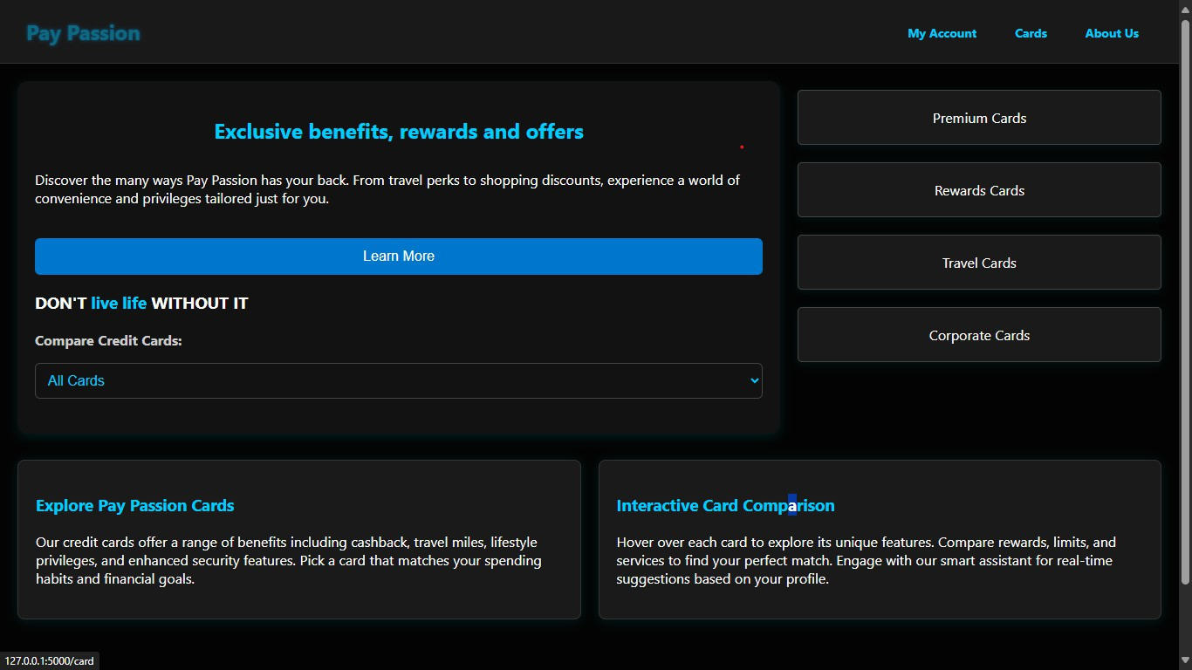**index.html page**

***FIGURE:6.1 Index Page***

* 1. **login.html page**

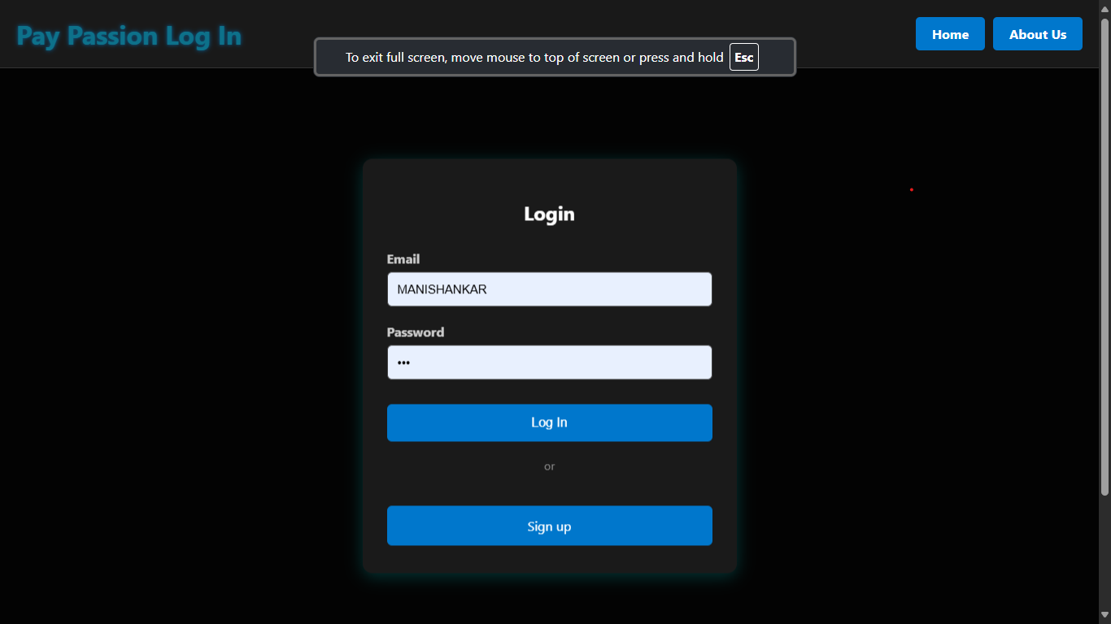

***FIGURE:6.2Login Page***

* 1. **apply.html**

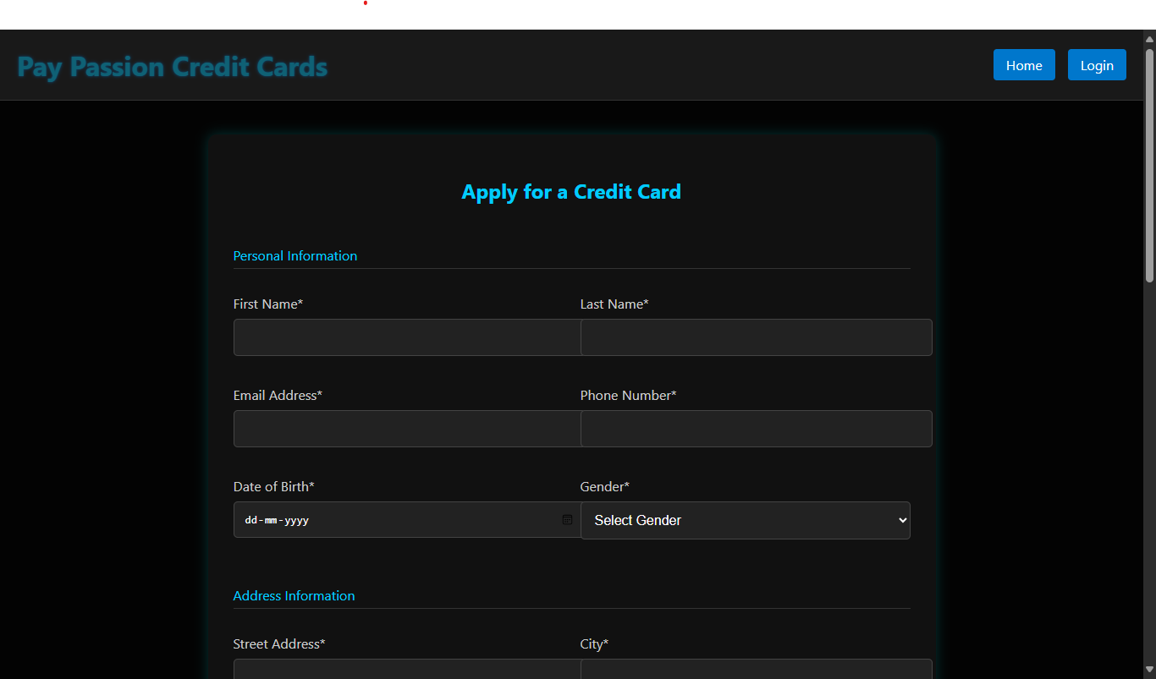

***FIGURE:6.3.1 Apply Page***

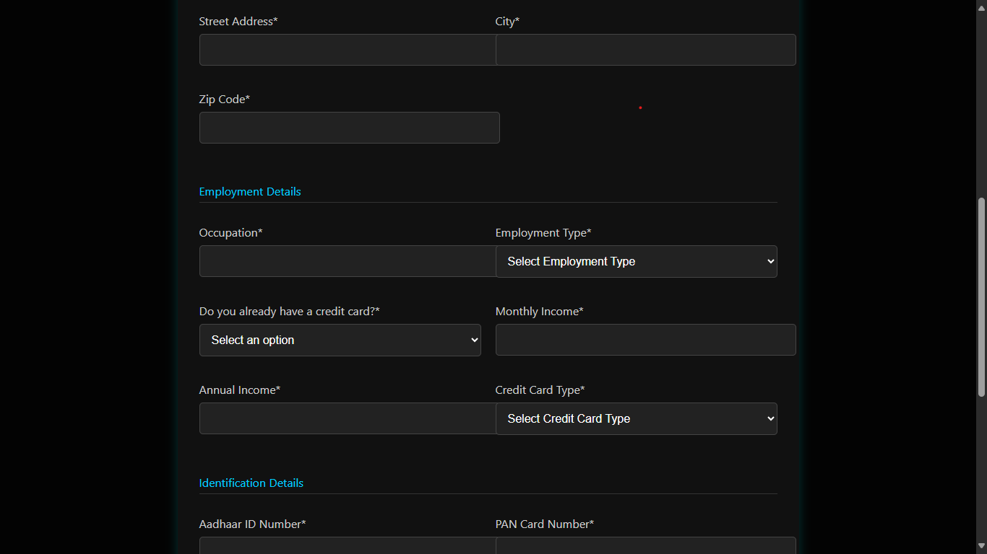

***FIGURE:6.3.2Apply Page***

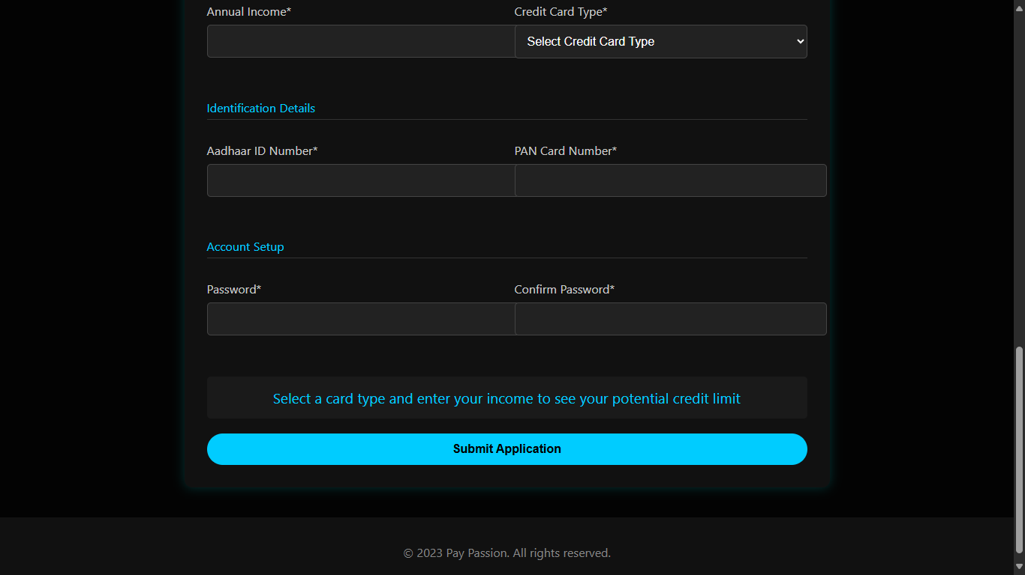

***FIGURE:6.3.3 Apply Page***

* 1. **success.html**

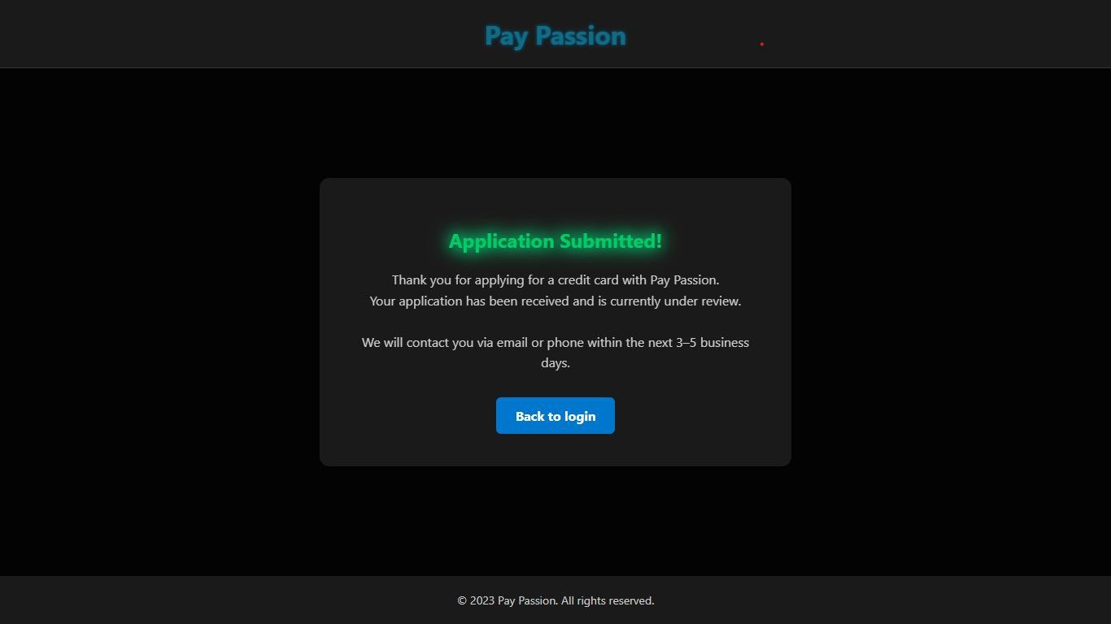

***FIGURE:6.4 Success Page***

* 1. **account_details.html**

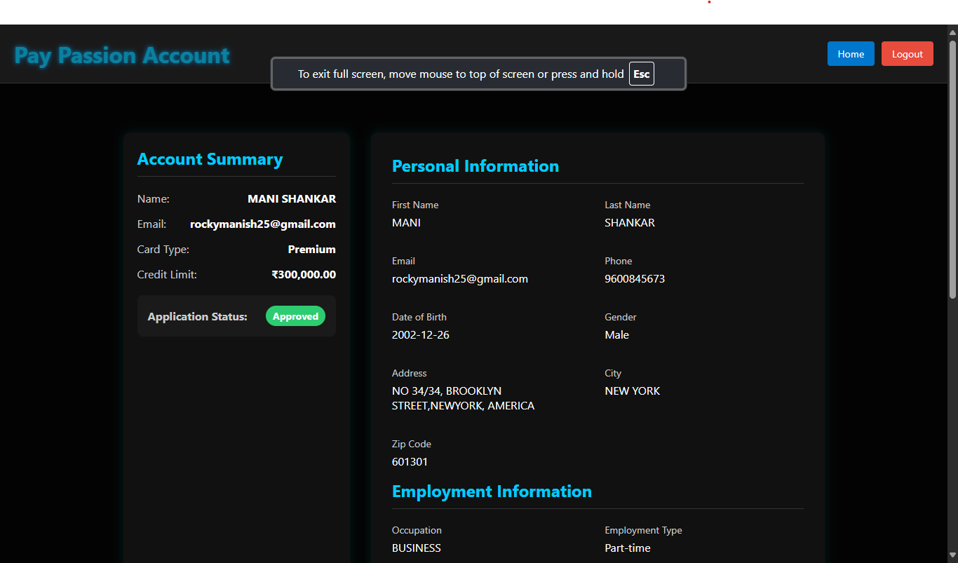

***FIGURE:­6.5.1 Account Details Page***

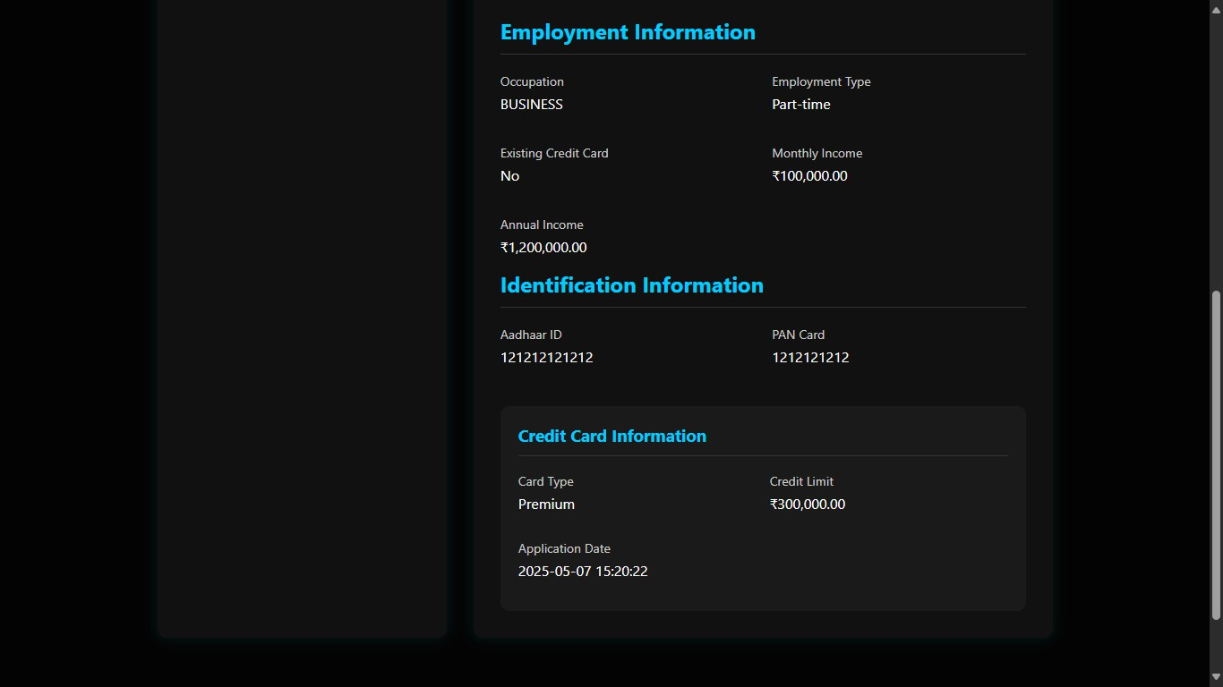

***FIGURE:6.5.2 Account Details Page***

* 1. **admin.html**

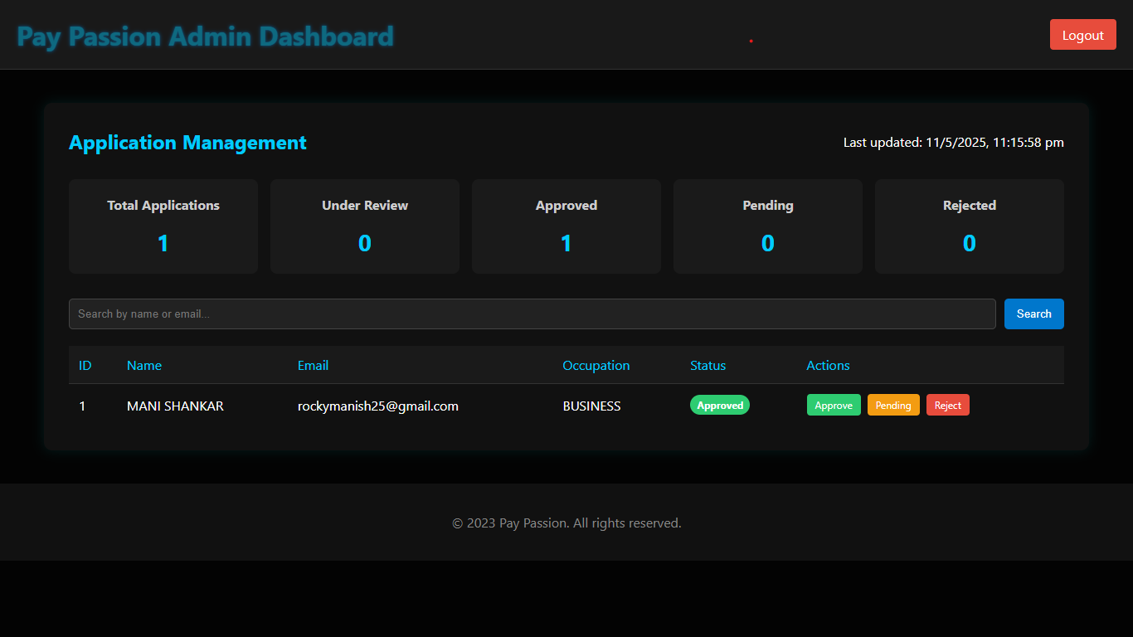

***FIGURE:6.6 Admin Page***

* 1. **card.html**

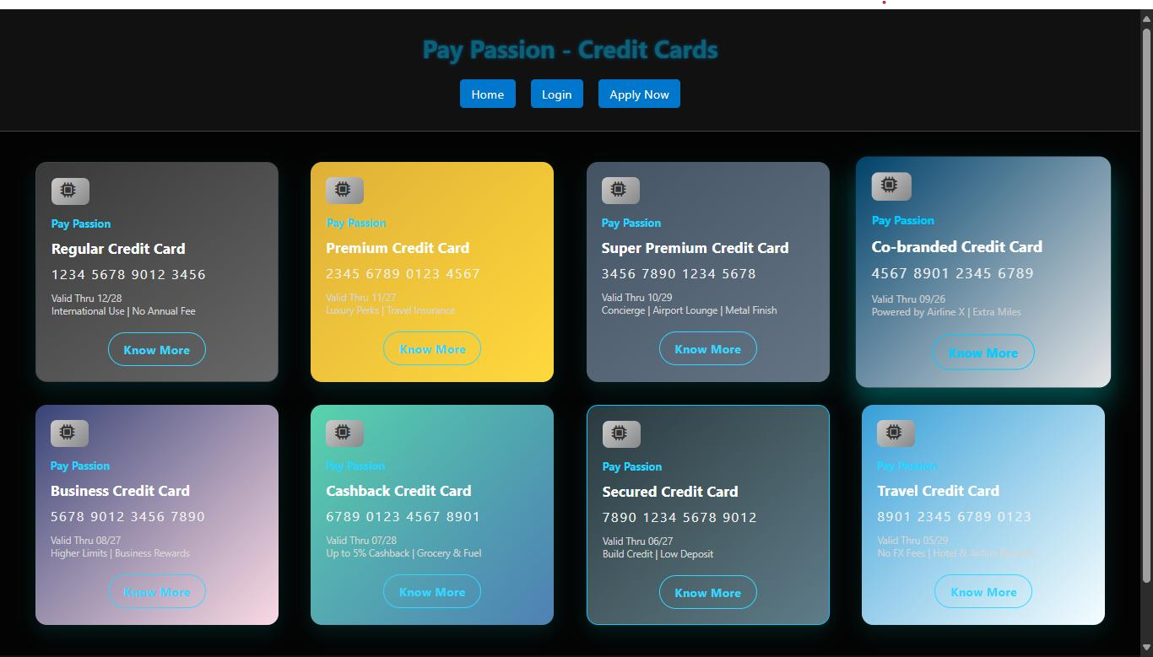

***FIGURE:6.7 Card Page***

* 1. **apply-regular.html**

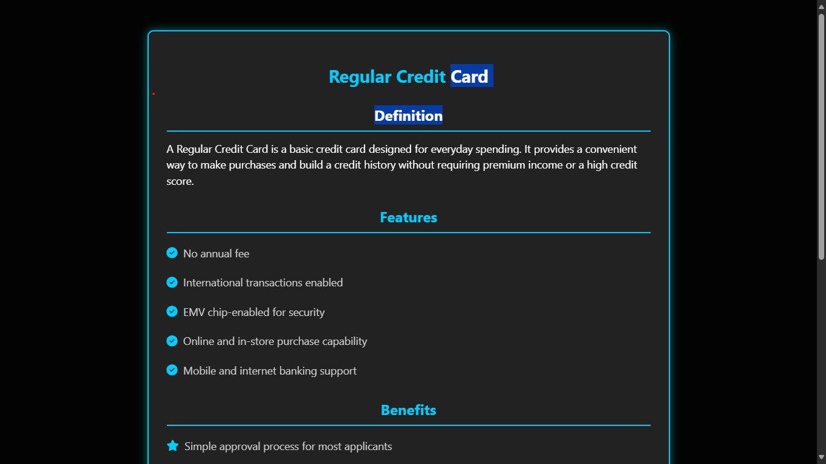

***FIGURE:6.8.1 Regular Card Info Page***

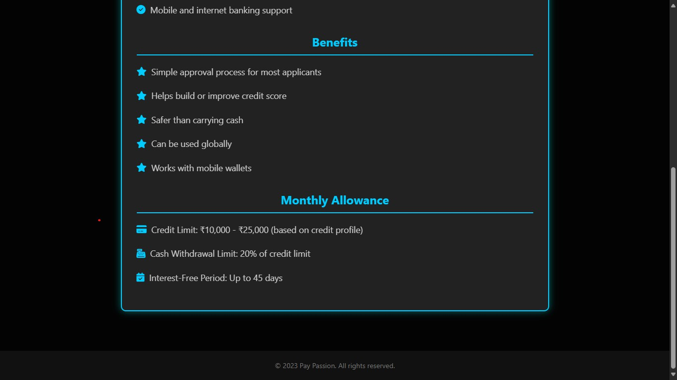

***FIGURE:6.8.2 Regular Card Info Page***

* 1. **apply_Travel.html**

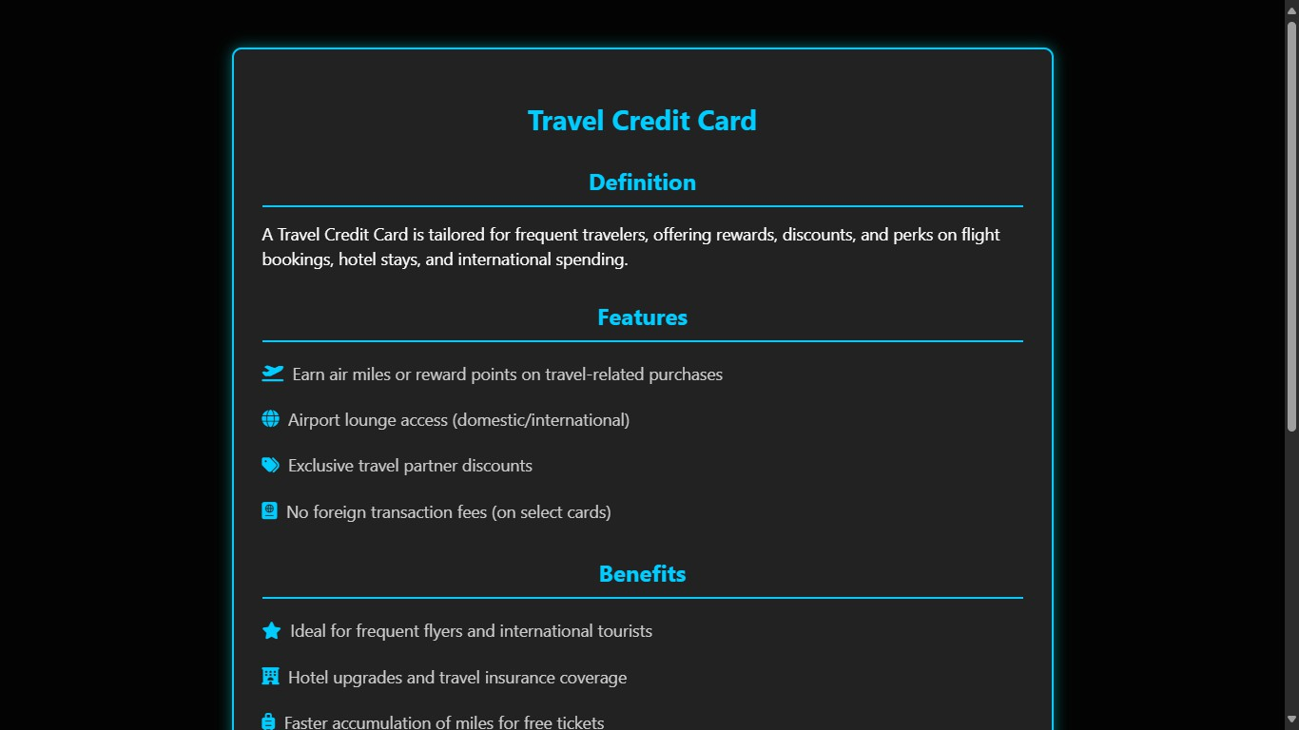

***FIGURE:6.9.1 Travel Card Info Page***

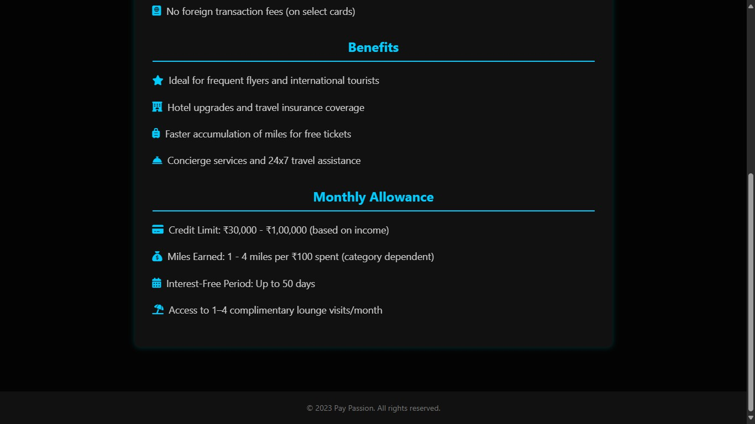

***FIGURE:6.9.2 Travel Card Info Page***

* 1. **apply_superpremium.html**

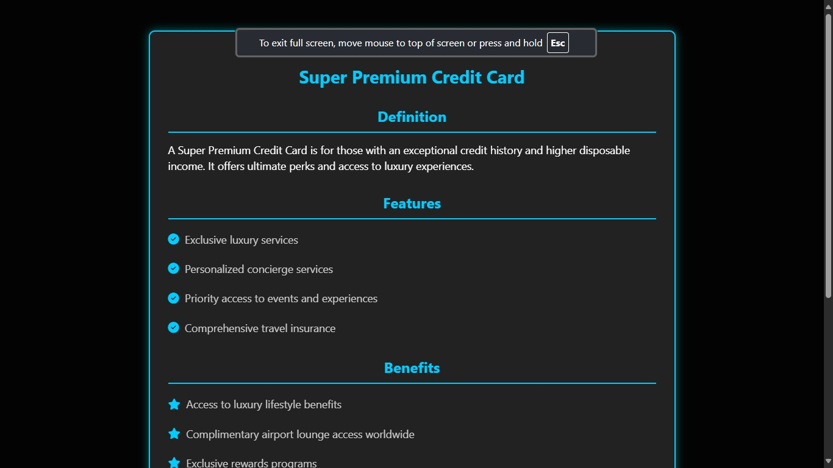

***FIGURE:6.10.1 Super Premium Card Info Page***

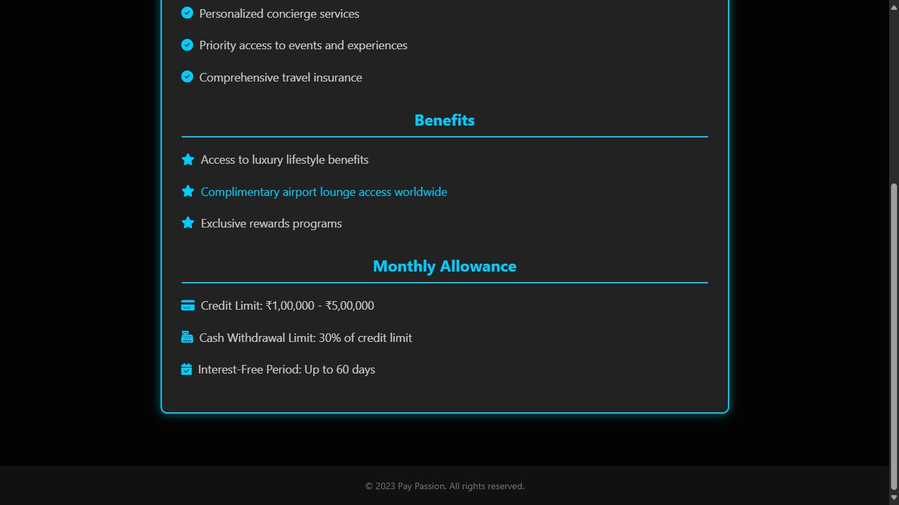

***FIGURE:6.10.2 Super Premium Card Info Page***

* 1. **apply_Secured.html**

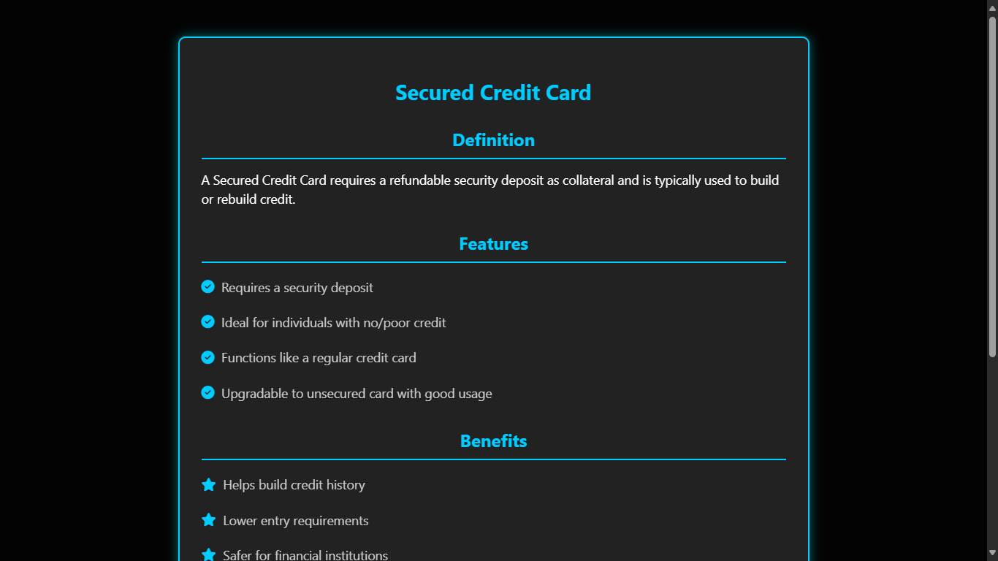

**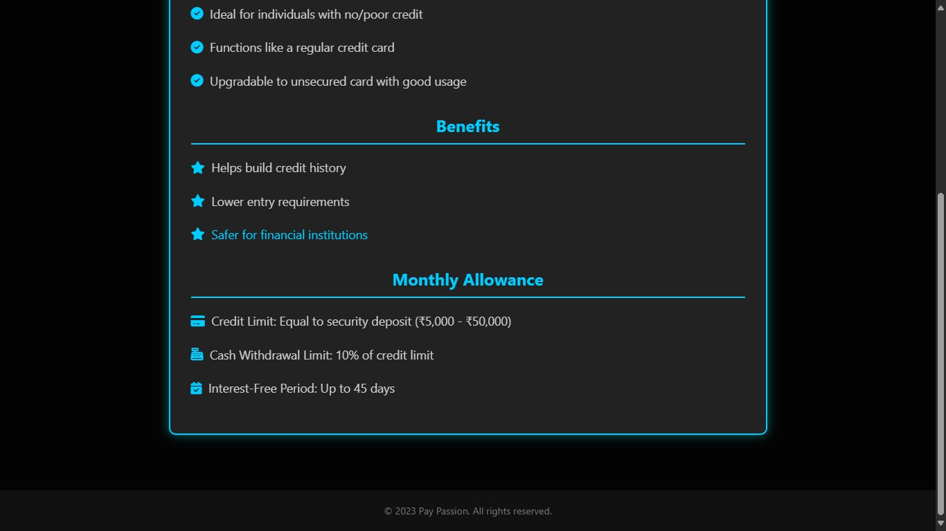*FIGURE:6.11.1 Secured Card Info Page***

***FIGURE:6.11.2 Secured Card Info Page***

* 1. **apply_premium.html**

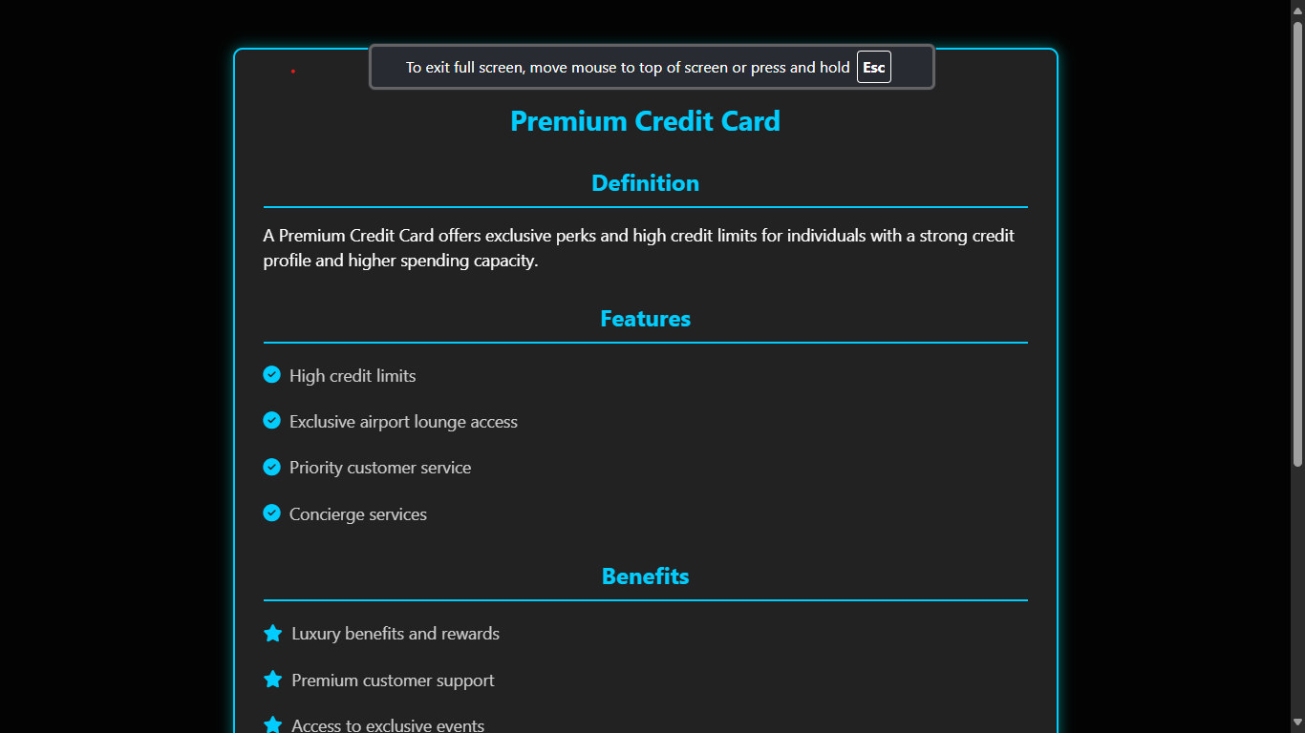

**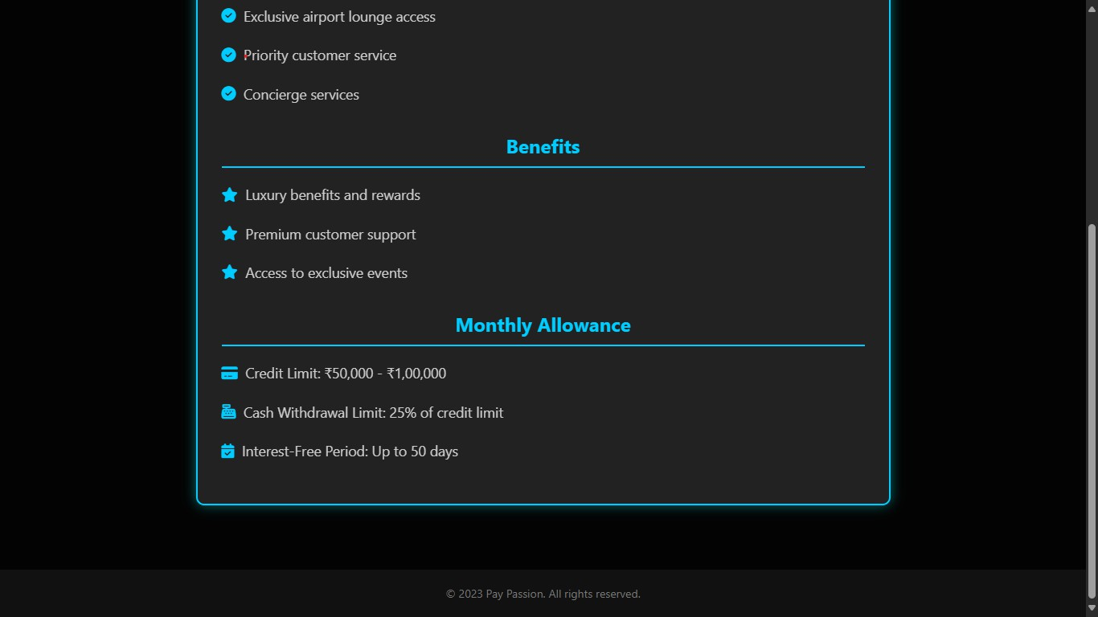*FIGURE:6.12.1 Premium Card Info Page***

***FIGURE:6.12.2 Premium Card Info Page***

* 1. **apply_Co-branded.html**

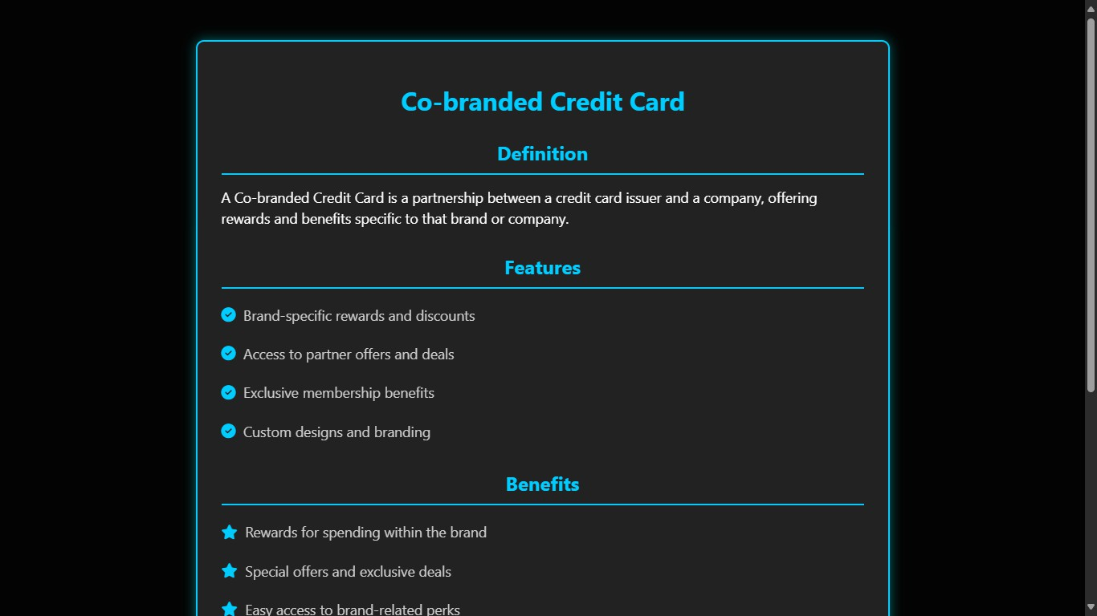

**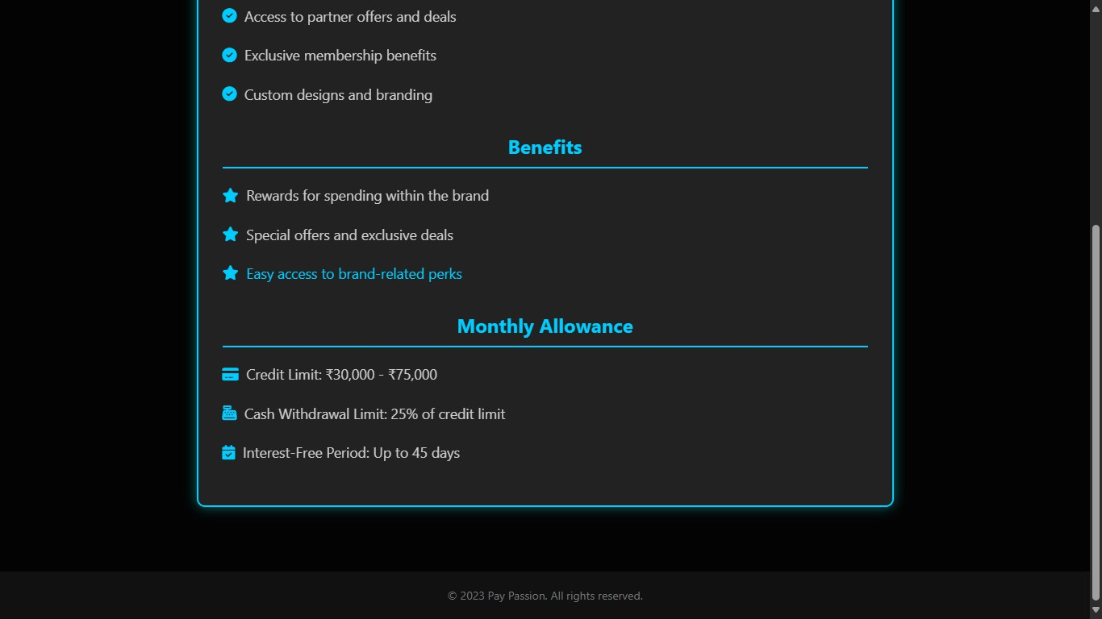*FIGURE:6.13.1 Co_Branded Card Info Page***

***FIGURE:6.13.2 Co-Branded Card Info Page***

* 1. **apply_Cashback.html**

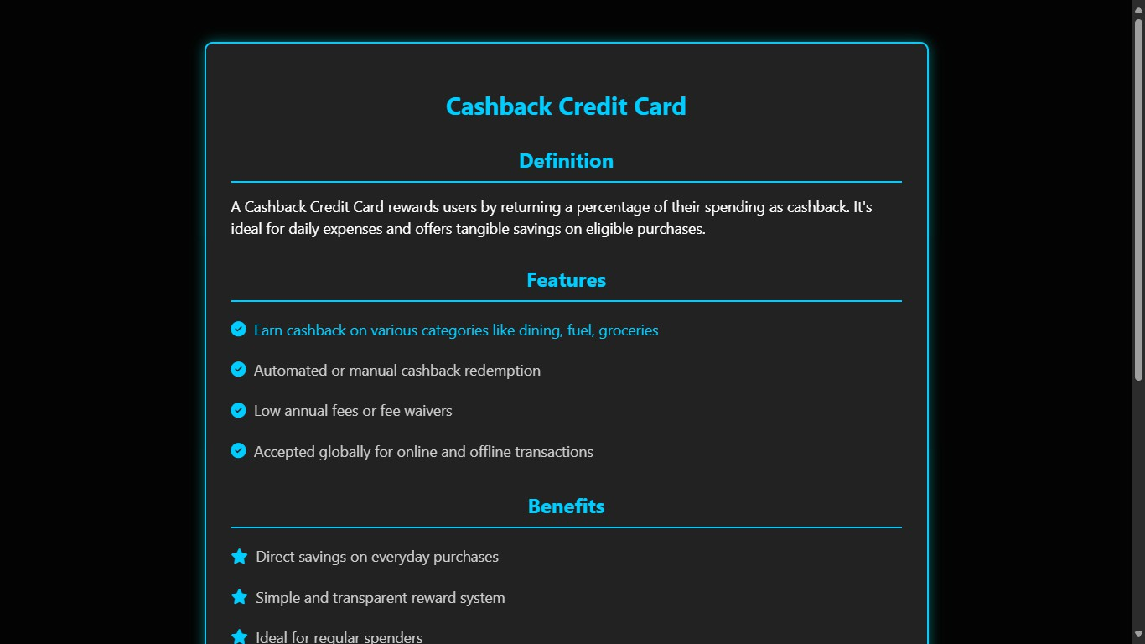

**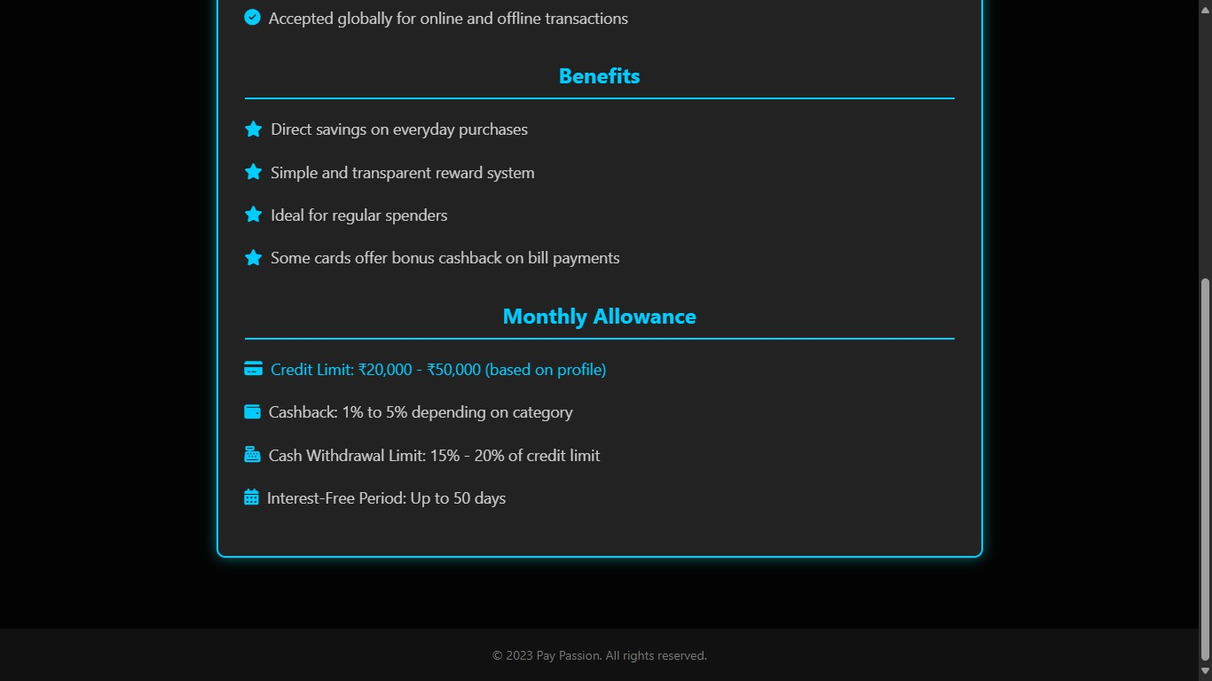*FIGURE:6.14.1 Cashback Card Info Page***

***FIGURE:6.14.2 Cashback Card Info Page***

* 1. **apply_Business.html**

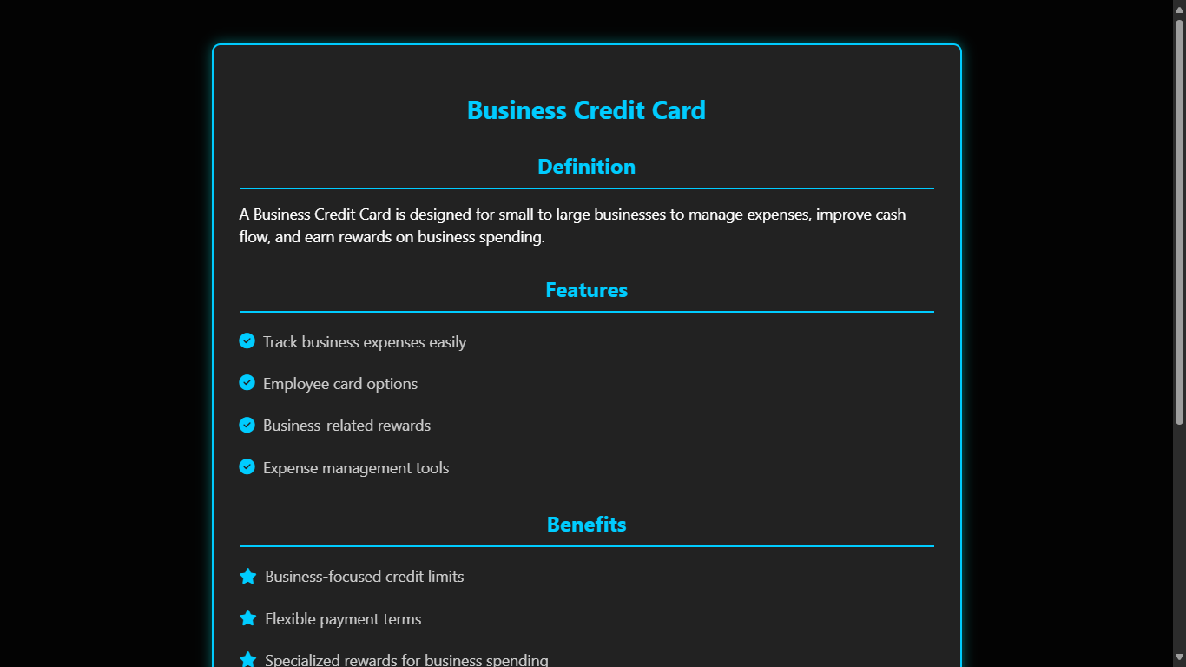

**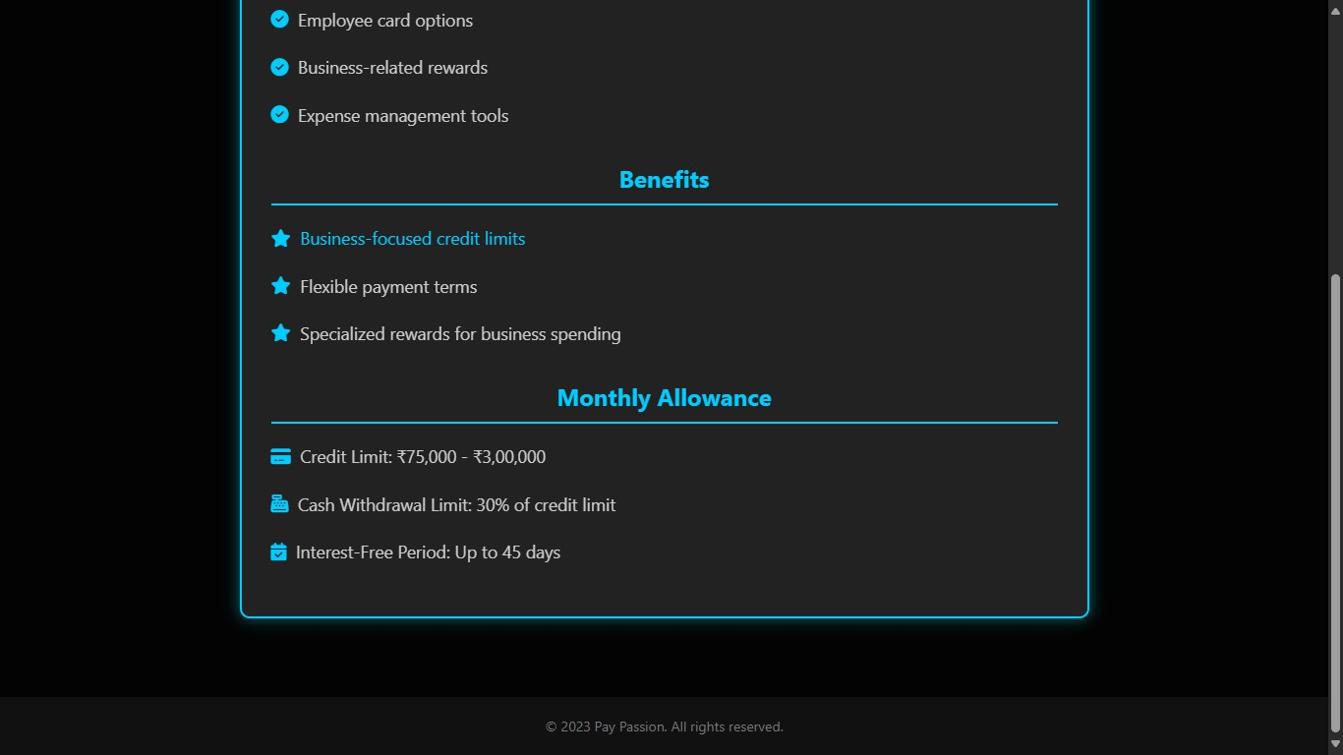*FIGURE:6.15.1 Business Card Info Page***

***FIGURE:6.15.2 Business Card Info Page***

* 1. **aboutus.html**

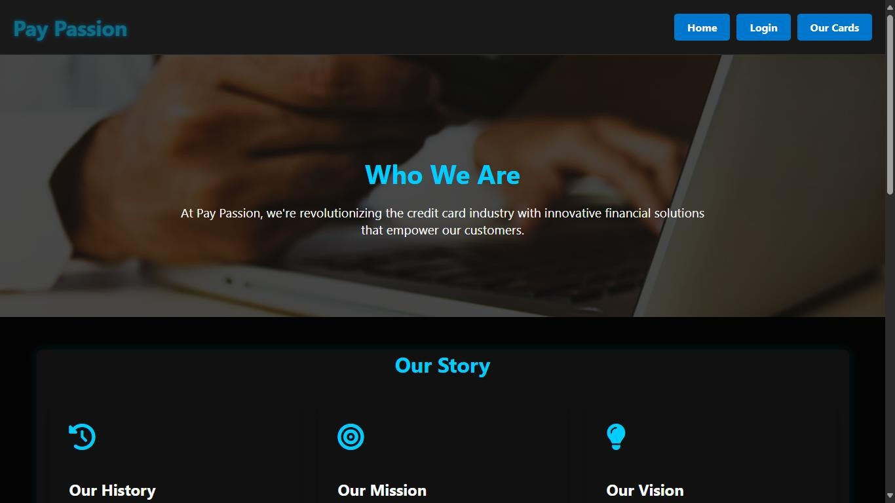

***FIGURE:6.16.1 About us Card Info Page***

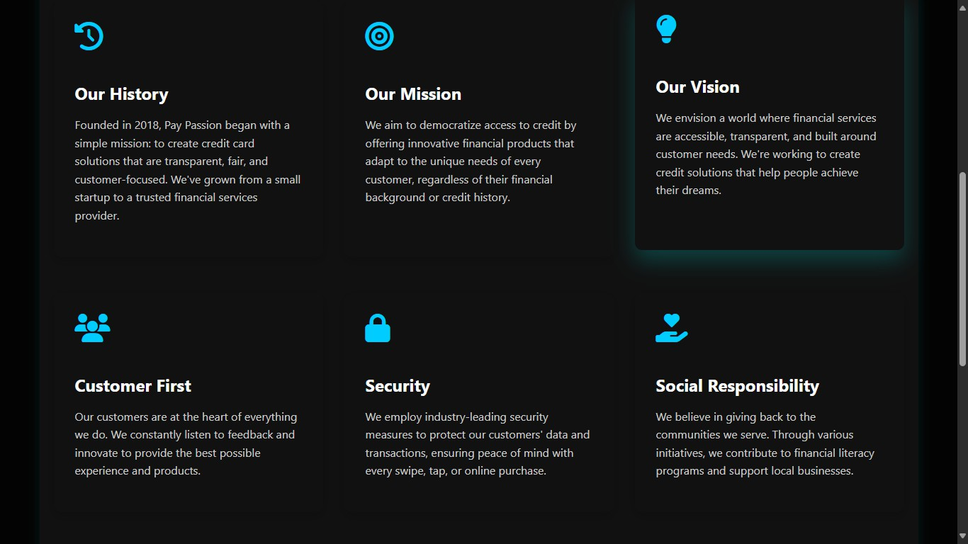

***FIGURE:6.16.2 About us Card Info Page***

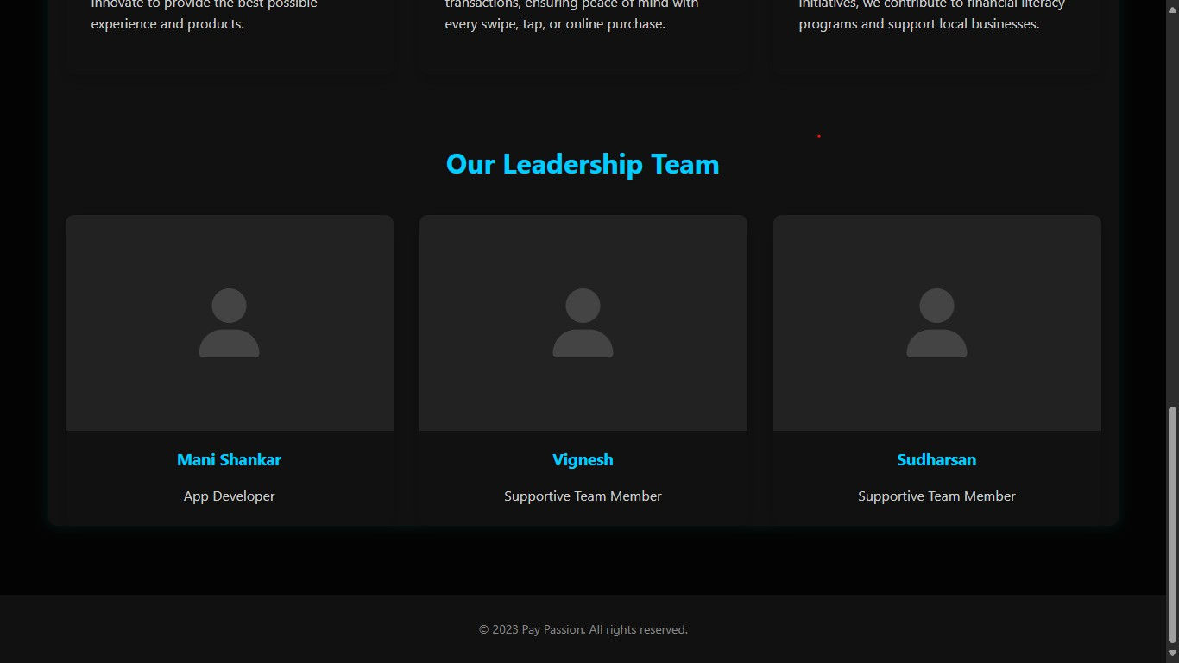

***FIGURE:6.16.3 About us Card Info Page***

1. **Conclusion**

The Pay Passion credit card web application stands as a testament to the power and versatility of full-stack web development when applied to the financial technology (fintech) space. It is not merely a demonstration of technical capabilities but a complete, thoughtfully engineered product that bridges the gap between user needs and technological solutions in the realm of digital financial services. This project was conceptualized with the goal of transforming the often complex and outdated experience of credit card management into a modern, intuitive, and engaging process. It encapsulates the synergy between front-end elegance and back-end robustness, ensuring that every user interaction is smooth, secure, and purposeful.

From the onset, the front-end of Pay Passion was crafted with a focus on both form and function. Built using HTML, CSS, and JavaScript, the user interface embraces a sleek, dark-themed aesthetic that resonates with modern design trends and delivers an immersive visual experience. Careful attention was paid to layout responsiveness, ensuring compatibility across devices of various screen sizes—from desktops to tablets to mobile phones. The application incorporates dynamic animations and floating effects that not only enrich the visual appeal but also guide user interactions in a natural and intuitive manner. Each credit card option within the application has its own dedicated section that visually differentiates it through unique backgrounds, icons, and styling.

The educational value of the project cannot be overstated. For aspiring full-stack developers, Pay Passion serves as an excellent example of how diverse technologies can be orchestrated into a cohesive, user-centric application. It combines frontend technologies like HTML5, CSS3, and vanilla JavaScript with backend technologies including Python, Flask, SQLite, and Jinja2 templating. Furthermore, it demonstrates the implementation of key software development principles such as MVC (Model- View-Controller), session handling, secure authentication, CRUD operations, and RESTful routing. These are essential skills for any developer aiming to work in the modern web ecosystem, especially in fintech, which demands both technical proficiency and high standards of data security and user privacy.

In conclusion, the Pay Passion credit card application represents more than just a functional website—it is a reflection of comprehensive design thinking, effective implementation, and user-focused development. It addresses a real-world problem— simplifying credit card management—and proposes a practical, elegant, and scalable solution. By integrating a responsive front-end with a secure, Python-powered back- end, the application exemplifies what is achievable in modern full-stack development. It offers a compelling experience for end-users and robust tools for administrators, making it ideal for both personal finance management and educational demonstration. As digital banking continues to evolve, projects like Pay Passion offer a glimpse into the future of user-friendly, secure, and efficient fintech applications.

1. **Future Enchancement**
2. Real-Time Transaction Monitoring

Implementing real-time tracking of credit card usage can provide users with immediate insights into their expenses and due payments.

* + Live updates of transactions
  + Spending alerts via email or SMS
  + Monthly spending breakdown charts

1. AI-Powered Card Recommendations

Machine learning algorithms can be used to suggest credit cards based on a user’s spending habits, income, and lifestyle.

* + Personalized card suggestions
  + Dynamic learning from transaction history
  + Improved user satisfaction through tailored experiences

1. Mobile Application Integration

To improve accessibility, a dedicated mobile app or mobile-optimized version of the platform can be developed.

* + Native apps for Android and iOS
  + Push notifications for due dates or offers
  + Touch and face ID login features for convenience

1. Enhanced User Dashboard

The user interface can be expanded to include a comprehensive dashboard for managing all card-related activities.

* + Credit limit tracking
  + Reward points summary
  + EMI tracking and conversion options

1. Two-Factor Authentication (2FA)

To strengthen security, 2FA can be implemented during login or high-risk actions.

* + OTP via SMS or email
  + Authenticator app integration
  + Customizable security settings for users